Web Design and Development

4COSC011W

Report

Author: Sachintha Chamod

Student ID: 20221948 / w2053013

Group Number: 05

Group Name: CLIMATE WARRIORS

Student Role : Student 02

Contents

1. Introduction 4

1.1 Team Members and Task Allocation 4

1.2 Website topic/theme 6

1.3 Contributions 6

1 Technical Discussion 6

1.1 Implementation 7

1.2 Task completion checklist 10

2 Webpage Validation Statement 11

3 Janet 11

4 Self-reflection 11

References 12

Appendices 12

Appendix A: Code 13

Appendix B: Screenshots 73

Appendix C: Screenshots - Webpage Validation Evidence 81

Appendix D: Task Completion Checklist 84

List of Tables

Table 1 - Meeting Table **Error! Bookmark not defined.**

Table 2 - Student 2 tasks **Error! Bookmark not defined.**

List of Figures

Figure 1 - Feedback Form 73

Figure 2 - Content Page 1.1 73

Figure 3 - Content Page 1.2 74

Figure 4 - Content Page 1.3 74

Figure 5 - Content Page 1.4 75

Figure 6 - Content Page 1.5 75

Figure 7 - Content Page 1.6 76

Figure 8 - Content Page 1.7 76

Figure 9 - Content Page 1.8 77

Figure 10 - Home Page 1.1 77

Figure 11 - Home Page 1.2 78

Figure 12 - Home Page 1.3 78

Figure 13 - Home Page 1.4 79

Figure 14 - Home Page 1.5 79

Figure 15 - Home Page 1.6 80

Figure 16 - Home Page 1.7 80

Figure 17 - Home Page Validation 81

Figure 18 - Feedbak Page Validation 82

Figure 19 - Content Page 1 Validation 82

Figure 20 - Content Page 2 Validation 83

Figure 21 - Content Page 3 Validation 83

# Introduction

As Student 2, my major goal in our website development project was to create a unified and user-friendly design that addressed the serious subject of climate change. Beginning with the fundamental features, I planned and produced the website brand, creating a visually appealing logo that reflects our objective. Speaking of mission, I painstakingly crafted the website's overarching goal, hoping to motivate visitors to connect with climate change problems and take real action.

The navigation bar was a critical component of user experience design, deliberately designed to enable straightforward access to crucial content sections such as resources, articles, and ways to get engaged. By incorporating user-friendly input fields and rigorous validation procedures, I hoped to improve user involvement while maintaining data correctness. Error management was also crucial, so I developed techniques to kindly lead users through any mistakes or oversights.

Furthermore, I included facilities for evaluating and amending entries, allowing individuals to improve their contributions. Finally, the confirmation phase acted as a comforting milestone, confirming the successful execution of tasks and increasing user trust. In conclusion, my contributions to the website project focused on developing a dynamic platform that not only teaches and informs but also motivates collective action against climate change.

## Team Members and Task Allocation

1. Student 1

* Website mission
* Group members
* Redirection
* Loader image
* Product showcase
* Product options
* Product selection
* Order summary (basket)
* Checkout summary
* Checkout system feedback

1. Student 2

* Website Identity (Logo)
* Website Mission
* Navigation Bar
* Links to content
* Input fields
* Validation
* Error handling
* Preview
* Edit
* Confirmation

1. Student 3

* Prompts to collect the user information
* Progressive display of user output
* Progress completion
* Feedback and confirmation
* Interactive thumbnails
* Extended details of thumbnails

1. Student 4

* Interactive thumbnails
* Extended details of thumbnails
* Customization of page color, font style
* SVG
* Interactive
* Accessible
* Responsive

## Website topic/theme

* Topic – CLIMATE ACTION
* Theme – CLIMATE CHANGE

Climate change is the most pressing issue of our time, requiring immediate, coordinated action. As temperatures rise and catastrophic weather occurrences increase, immediate action is required. Transitioning to renewable energy sources like solar and wind power is critical for reducing greenhouse gas emissions. Furthermore, international cooperation is essential for executing comprehensive goals and agreements. Encourage sustainable initiatives, such as reforestation and carbon footprint reduction, at both the local and individual levels. We can reduce the effects of climate change and protect the earth for current and future generations by emphasizing innovation, cooperation, and environmentally responsible decisions, assuring a sustainable and resilient future.

## 1.3 Contributions

# Technical Discussion

|  |  |  |  |  |
| --- | --- | --- | --- | --- |
| Meeting | Date & Time | Objective | Attended | Contribution |
| 1 | March 21, 2024  8.00 – 9.30 p.m. (Online) | Select student roles and discuss about course  And student roles. | Yes | I get student role 2 as my role. |
| 2 | March 23, 2024  7.00 – 8.30  p.m.  (Online) | Discuss the structure of our website. | Yes | Discussing about our webpage structure and showing our present work to others. |
| 3 | March 27, 2024  10.00 – 11.30 p.m. (Online) | Design website logo | Yes | Discussed with team members about our web page logo and decide to create 2 logos. |
| 4 | Mar 30, 2024  6.00 – 8.30 p.m. (Online) | Discuss all dauts and unclear points | Yes | Discussed all our dauts with each other and clear everything and progress to work. |
| 5 | April 03, 2024  7.30 – 9.30 p.m. (Online) | Testing website functionality and user experience, and finalize | Yes | Testing our website and finalize it. |

Table 1 - Meeting Table

## Implementation

1. Activating the navigation bar

To implement the navigation bar across all pages, I started by creating a reusable HTML component for the navigation bar. This component includes a <nav> element containing a link item <a> for each navigation link. Each item has an anchor (<a href="#">) element that links to related pages.

<nav class="navbar">

        <a href="#home">home</a>

        <a href="#about">about</a>

        <a href="#Infor">Infor</a>

        <a href="#">Shop</a>

        <a href="#">Register</a>

        <a href="#">Site Map</a>

        <a href="#">Gallery</a>

        <a href="#Feedback.html">Feedback</a>

    </nav>

For styling the navigation bar, I used CSS to apply consistent styles across all pages. I used flexbox or grid layout to align the navigation links horizontally and centered them within the navigation bar. I also applied styles for hover and active states to provide visual feedback to users.

  header .navbar a{

    font-size: 2rem;

    margin-left: 2rem;

    color:#333;

  }

  header .navbar a:hover{

    color:var(--red);

  }

2. Template Implementation

To implement the template across all pages, I created an HTML template file containing the common structure shared by all pages, such as the <head> section, navigation bar, and footer.

HTML,

<!DOCTYPE html>

<html lang="en">

<head>

    <meta charset="UTF-8">

    <meta name="viewport" content="width=device-width, initial-scale=1.0">

    <title>Climate Warriors</title>

    <!-- font awesome cdn link (font type)  -->

    <link rel="stylesheet" href="https://cdnjs.cloudflare.com/ajax/libs/font-awesome/5.15.3/css/all.min.css">

    <!-- custom css file link  -->

    <link rel="stylesheet" href="style.css">

</head>

<body>

<!-- header section starts  -->

<header>

    <a href="#" class="logo"><i class="fas fa-child"></i>Climate Warriors</a>

    <div id="menu-bars" class="fas fa-bars"></div>

    <nav class="navbar">

        <a href="#home">home</a>

        <a href="#about">about</a>

        <a href="#Infor">Infor</a>

        <a href="#">Shop</a>

        <a href="#">Register</a>

        <a href="#">Site Map</a>

        <a href="#">Gallery</a>

        <a href="#Feedback.html">Feedback</a>

    </nav>

</header>

Footer,

<div class="footer">

    created by <span> Climate Warriors - G32 </span> | 2024 - all rights reserved!

</div>

On each page, I used JavaScript to dynamically load the template content into the page's <body> element using technique. This approach ensures consistency across all pages and makes it easy to update the template without modifying each individual page.

JavaScript,

<script>

let menu = document.querySelector('#menu-bars');

let navbar = document.querySelector('.navbar');

menu.addEventListener('click', () =>{

    menu.classList.toggle('fa-times');

    navbar.classList.toggle('nav-toggle');

});

window.onscroll = () =>{

    menu.classList.remove('fa-times');

    navbar.classList.remove('nav-toggle');

}

</script>

</body>

</html>

For all my content pages and for my Feedback page I used same template I created earlier. When I created home page, navigation bar I faced several challengers. One challenge I encountered was ensuring responsiveness across different screen sizes. To address this, I utilized media queries in CSS to adjust the layout and styling based on screen width, ensuring a seamless user experience across devices. Another challenge was maintaining consistency in styling and layout across pages. To overcome this, I carefully designed the template and navigation bar to be reusable components, minimizing the need for redundant code and ensuring consistency throughout the website.

Throughout the implementation process, I consulted lecture notes on HTML, CSS, and JavaScript techniques, as well as online resources such as MDN Web Docs and CSS-Tricks for additional guidance and best practices. By overcoming these challenges and following a systematic approach to implementation, I was able to create a cohesive and user-friendly website that meets the requirements outlined in the coursework specification.

3. Feedback Form Implementation

For the implementation of the feedback form, I followed a structured approach utilizing HTML, CSS, and JavaScript.

HTML Structure:

I began by designing the HTML structure of the feedback form, ensuring semantic markup for accessibility and SEO benefits. Each form element was wrapped in appropriate containers and labelled for clarity and accessibility.

CSS Styling:

Another challenge was integrating preview functionality seamlessly into the form. This required a balance between providing users with a clear preview of their feedback while maintaining a user-friendly interface. Through iterative testing and refinement, I achieved a solution that enhances user confidence without overwhelming them with unnecessary complexity. Overall, the implementation of the feedback form provided valuable insights into the importance of user-centric design and the iterative development process. By prioritizing user experience and employing best practices in web development, I was able to create a feedback form that meets the needs of both users and stakeholders.

## Task completion checklist

After examining the tasks allocated to me for implementation, as described in Appendix D, I am delighted to report that the vast majority have been successfully performed. The Home Page, Navigation Bar, Content Page, and Page Editor were all successfully constructed and incorporated into the website. In addition, I created the navigation bar and used it on all pages to provide uniformity and simplicity of navigation for users. Furthermore, I built and implemented a website template that has been customized and applied to all pages, ensuring design and layout consistency throughout.

Furthermore, I supplied extra CSS to improve the website's visual appeal and functionality, as well as adding more interactive components to engage users even more. Finally, I was successful in uploading the website to the web server, making it available to the desired audience. Overall, I completed the assigned responsibilities with careful planning, execution, and attention to detail, helping to ensure the successful creation and implementation of our climate change education website.

# Webpage Validation Statement

Three web pages, including the home page, feedback form, and content page, passed validation without issue. Appendix C offers screenshots that confirm the error-free validation findings for each page. This assures that our website meets high standards of code integrity and accessibility, hence improving user experience and trustworthiness.

# Janet

Ensuring compliance with Janet's Regulations is critical to me since I emphasize equality and accessibility on my website. By certifying my website and confirming the absence of mistakes, I demonstrate my commitment to following these rules. My website design prioritizes straightforward navigation, legible writing, and keyboard accessibility, which aligns with Janet's principles for meeting various user needs. Furthermore, I carry out extensive testing and validation methods to ensure interoperability across multiple devices and assistive technologies, ensuring equal access for all users, regardless of impairments or limits. In summary, my website's adherence to Janet Regulations demonstrates my commitment to fostering diversity and creating an accessible online environment for everybody.

# Self-reflection

The coursework project on climate change website building taught me significant lessons about team dynamics and personal growth. Collaborating with colleagues, I found enormous pleasure in the creative interchange of ideas and the joint effort toward a shared objective. However, obstacles arose, notably in organizing schedules and assuring fair participation. Despite the hardships, the event taught me valuable lessons about collaboration. Effective communication, adaptation, and compromise were critical for managing conflicting viewpoints and increasing team productivity.

This project taught me a variety of skills that will be useful in both academic and professional settings. I strengthened my project management abilities by navigating work delegation and timeline management, ensuring that the project ran successfully. Furthermore, my knowledge of website-building tools and communication platforms improved tremendously, which helped our project go smoothly.

Recognizing my talents, I discovered that my organizational skills and ability to stay focused on project objectives proved to be valuable advantages. I successfully handled timelines and inspired the team to achieve our joint goals. However, I saw places for improvement, particularly in allocating jobs more fairly and minimizing burnout by spreading responsibility more equitably across teammates.

Looking ahead, I am devoted to incorporating improvement techniques in future initiatives. A clearer definition of roles and duties from the start, together with regular check-ins and milestone tracking, will improve project efficiency and reduce possible disputes. Furthermore, maintaining an open communication and feedback culture will guarantee that joint efforts continue to grow and succeed.

In conclusion, the coursework project served as a platform for personal and professional development, teaching significant lessons about cooperation, collaboration, and successful project management. As I continue my academic path, I am optimistic that these experiences will serve as a strong basis for success in future endeavors.

# References

Reference list

Awesome Contact Form Using HTML & CSS & JavaScript. (no date). *www.youtube.com*. Available from <https://youtu.be/rpujWVkmiPE?si=2JrrnuqfGmYVfhdk> [Accessed 21 March 2024].

Boxicons : Premium web friendly icons for free. (no date). *boxicons.com*. Available from <https://boxicons.com/?query=> [Accessed 20 March 2024].

Download Free Vectors, Clipart, Images & Backgrounds. (2024). *Vecteezy*. Available from <https://www.vecteezy.com/free-vector>.

Freepik. (2023). Freepik - Free Graphic resources for everyone. *Freepik*. Available from <https://www.freepik.com/> [Accessed 24 March 2024].

Green Color Palettes - Coolors. (no date). *Coolors.co*. Available from <https://coolors.co/palettes/popular/green> [Accessed 26 March 2024].

How To Make a Feedback Form With Html And Css| Amazing Feedback Form With Html And Css||By zainXpert. (no date). *www.youtube.com*. Available from <https://youtu.be/yaTLj4BB0T4?si=AQjwYwod7PmdOX0G> [Accessed 21 March 2024].

HTML Reference. (no date). *www.w3schools.com*. Available from <https://www.w3schools.com/tags/ref_byfunc.asp> [Accessed 15 March 2024].

Pexels. (no date). Free Stock Photos. *Pexels.com*. Available from <https://www.pexels.com/> [Accessed 25 March 2024].

PNGWing - Exclusive png design images. (no date). *PNGWing*. Available from <https://www.pngwing.com/>.

Unsplash. (2022). Beautiful Free Images & Pictures. *Unsplash*. Available from <https://unsplash.com/> [Accessed 20 March 2024].

# Appendices

## Appendix A: Code

Home page

HTML part,

<!DOCTYPE html>

<html lang="en">

<head>

<meta charset="UTF-8">

<meta name="viewport" content="width=device-width, initial-scale=1.0">

<title>Climate Warriors</title>

<!-- font awesome cdn link (font type) -->

<link rel="stylesheet" href="https://cdnjs.cloudflare.com/ajax/libs/font-awesome/5.15.3/css/all.min.css">

<!-- custom css file link -->

<link rel="stylesheet" href="style.css">

</head>

<body>

<!-- header section starts -->

<header>

<a href="#" class="logo"><i class="fas fa-child"></i>Climate Warriors</a>

<div id="menu-bars" class="fas fa-bars"></div>

<nav class="navbar">

<a href="#home">home</a>

<a href="#about">about</a>

<a href="#Infor">Infor</a>

<a href="#">Shop</a>

<a href="#">Register</a>

<a href="#">Site Map</a>

<a href="#">Gallery</a>

<a href="#Feedback.html">Feedback</a>

</nav>

</header>

<!-- header section ends -->

<!-- home section starts -->

<section class="home background" id="home">

<div class="content">

<h1>welcome to Climate Warriors</h1>

<h3>Protect the word and help to bulid new climate</h3>

<p>The climate and environmental conditions are changing rapidly day by day with the new geological behavior pattern in the world. Although it has changed to a somewhat better state, its change to the worse has been increasing rapidly. What should we do in this situation? Shouldn't the environment be protected? How does the climate change like this?</p>

<a href="#" class="btn">learn more</a>

</div>

<div class="image">

<img src="images/Home.png" alt="">

</div>

</section>

<!-- home section ends -->

<!-- features section starts -->

<section class="features up-and-down" id="features">

<div class="box-container">

<h3 class="title">Why this important for you</h3>

<div class="box">

<img src="images/L-image1.png" alt="">

<div class="info">

<h3>Raise Awareness</h3>

<p> We teach climate change causes, effects and solutions, scientifically sound information, climate change mitigation and adaptation.</p>

</div>

</div>

<div class="box">

<img src="images/L-image2.png" alt="">

<div class="info">

<h3>Promote sustainable practices</h3>

<p>Promotion of sustainable practices and behaviors that reduce greenhouse gas emissions and environmental degradation, energy efficiency, waste reduction, practical advice on eco-friendly practices, Encourage sustainable lifestyle choices.</p>

</div>

</div>

<div class="box">

<img src="images/L-image3.png" alt="">

<div class="info">

<h3>Drive policies and advice</h3>

<p>We provide platforms for advocacy and mobilization to empower individuals and communities to engage in climate action. Informs about climate related policies and international agreements.</p>

</div>

</div>

</div>

<img class="stick" src="images/stick.png" alt="">

<div class="box-container">

<h3 class="title">Benefits of Choosing us</h3>

<div class="box">

<img src="images/R-image1.png" alt="">

<div class="info">

<h3>Educational Value</h3>

<p>We provide you with comprehensive and reliable information on climate science, impacts and solutions.Articles, reports and guides to their understanding of climate change issues.</p>

</div>

</div>

<div class="box">

<img src="images/R-image2.png" alt="">

<div class="info">

<h3>Community building</h3>

<p>We provide space to share your ideas, experiences and best practices, foster collaboration and networking opportunities.</p>

</div>

</div>

<div class="box">

<img src="images/R-image3.png" alt="">

<div class="info">

<h3>Action-Oriented Approach</h3>

<p> We empower you to transform knowledge into tangible actions and solutions. We encourage you to explore advocacy for policy change, support, resources and tools for sustainable business</p>

</div>

</div>

</div>

</section>

<!-- features section ends -->

<!-- about section starts -->

<section class="about background" id="about">

<div class="image">

<img src="images/About.png" alt="">

</div>

<div class="content">

<h3>About us</h3>

<p>Welcome to Climate Warriors, your trusted source for reliable information on climate change. Our mission is to raise awareness of the urgent challenges posed by climate change and empower you to take meaningful action. </p>

<p>Backed by scientific expertise, we strive to provide an accessible, accurate, and actionable understanding of the causes, effects, and solutions to climate change. Join us on our journey towards a more sustainable and resilient future for our planet and future generations.</p>

<a href="#" class="btn">learn more</a>

</div>

</section>

<!-- about section ends -->

<!-- Infor section starts -->

<section class="Infor up-and-down" id="Infor">

<h1 class="heading">More information for you</h1>

<div class="box-container">

<div class="box">

<img src="images/ClimateScience.jpg" alt="">

<a href="#">Understanding Climate Science</a>

<div class="info">

<h3>Understanding Climate Science</h3>

</div>

</div>

<div class="box">

<img src="images/MitigationStrategies.jpg" alt="">

<a href="#">Mitigation Strategies</a>

<div class="info">

<h3>Mitigation Strategies</h3>

</div>

</div>

<div class="box">

<img src="images/EffectsOfClimateChange1.jpg" alt="">

<a href="#">Effects of Climate Change</a>

<div class="info">

<h3>Effects of Climate Change</h3>

</div>

</div>

<div class="box">

<img src="images/AdaptationAndResilience.jpg" alt="">

<a href="#">Adaptation and Resilience</a>

<div class="info">

<h3>Adaptation and Resilience</h3>

</div>

</div>

<div class="box">

<img src="images/SustainableLifestyle.jpg" alt="">

<a href="#">Sustainable Lifestyle</a>

<div class="info">

<h3>Sustainable Lifestyle</h3>

</div>

</div>

<div class="box">

<img src="images/Counseling.jpg" alt="">

<a href="#">Counseling</a>

<div class="info">

<h3>Counseling</h3>

</div>

</div>

</div>

</section>

<!-- Infor section ends -->

<!-- Members section starts -->

<section class="Members background" id="Members">

<h1 class="heading">our active members</h1>

<div class="box-container">

<div class="box">

<img src="images/p1.png" alt="">

<h3>Jase Blevins</h3>

<span>Environmental Scientist</span>

<div class="share">

<a href="#" class="fab fa-facebook-f"></a>

<a href="#" class="fab fa-twitter"></a>

<a href="#" class="fab fa-instagram"></a>

<a href="#" class="fab fa-linkedin"></a>

</div>

<p>As an environmental scientist, I am an analytical and multidisciplinary problem solver. I am attentive, adaptive, and concerned about conservation. In my pursuit of a sustainable future, I develop solutions, effectively convey discoveries, and adhere to ethical norms.</p>

</div>

<div class="box">

<img src="images/p2.png" alt="">

<h3>Gage Owen</h3>

<span>Program Administrator</span>

<div class="share">

<a href="#" class="fab fa-facebook-f"></a>

<a href="#" class="fab fa-twitter"></a>

<a href="#" class="fab fa-instagram"></a>

<a href="#" class="fab fa-linkedin"></a>

</div>

<p>As a Program Administrator, I am responsible for program logistics, budget management, and staff coordination. I am committed to increasing program efficacy and impact while maintaining alignment with strategic objectives. Communication and collaboration are vital while working with team members, partners, and participants. With meticulous attention to detail and a desire to make a difference, I endeavor to ensure the success of every program I manage.</p>

</div>

<div class="box">

<img src="images/p3.png" alt="">

<h3>Molly Dalton</h3>

<span>Renewable Energy Engineer</span>

<div class="share">

<a href="#" class="fab fa-facebook-f"></a>

<a href="#" class="fab fa-twitter"></a>

<a href="#" class="fab fa-instagram"></a>

<a href="#" class="fab fa-linkedin"></a>

</div>

<p>As a Renewable Energy Engineer, I create and execute sustainable energy solutions, motivated by a desire to prevent climate change. I study energy systems, work with teams, and incorporate cutting-edge technology to improve efficiency and reduce environmental effects. My mission is to create renewable energy solutions to ensure a cleaner, more sustainable future.</p>

</div>

<div class="box">

<img src="images/pp4.png" alt="">

<h3>Marco Howell</h3>

<span>Assistant Manager of DRT</span>

<div class="share">

<a href="#" class="fab fa-facebook-f"></a>

<a href="#" class="fab fa-twitter"></a>

<a href="#" class="fab fa-instagram"></a>

<a href="#" class="fab fa-linkedin"></a>

</div>

<p>I support programs that address environmental concerns. I work on tactics, policies, and advocacy campaigns to improve sustainability. Working with teams, I evaluate data and push innovation to achieve beneficial environmental results. My mission is to help prevent climate change and create a sustainable future.</p>

</div>

</div>

</section>

<!-- Members section ends -->

<!-- Community section starts -->

<section class="Community up-and-down" id="Community">

<h1 class="heading">Get your membership</h1>

<div class="box-container">

<div class="box" style="background: url(images/summer.png) no-repeat;">

<h3>6 Months</h3>

<div class="price"><span>$</span>10</div>

<p>Exclusive content and perks for 6 months.

Uninterrupted access to premium features.

Engage with our community and receive special offers.</p>

<a href="#" class="btn">Buy...</a>

</div>

<div class="box" style="background: url(images/winter.png) no-repeat;">

<h3>One Year</h3>

<div class="price"><span>$</span>50</div>

<p>Full access to premium features for a year.

Connect with experts and join exclusive events.

Stay updated with new features and member benefits.</p>

<a href="#" class="btn">Buy...</a>

</div>

<div class="box" style="background: url(images/spring.png) no-repeat;">

<h3>3 Years</h3>

<div class="price"><span>$</span>140</div>

<p>Long-term access to premium content.

Thrive in our community with priority support.

Enjoy early access to updates and discounts.</p>

<a href="#" class="btn">Buy...</a>

</div>

</div>

</section>

<!-- Community section ends -->

<!-- contact section starts -->

<section class="contact background" id="contact">

<div class="row">

<div class="contact-info">

<div class="box">

<h3 class="title">contact details</h3>

<p> <i class="fas fa-map-marker-alt"></i> Spencer Building, Colombo 6, Sri Lanka - 121232. </p>

<p> <i class="fas fa-envelope"></i>ClimateW@gmail.com </p>

<p> <i class="fas fa-phone"></i> +123-456-7890 </p>

</div>

<div class="box">

<h3 class="title">follow us on</h3>

<a href="#" class="fab fa-facebook-f"></a>

<a href="#" class="fab fa-twitter"></a>

<a href="#" class="fab fa-instagram"></a>

<a href="#" class="fab fa-linkedin"></a>

</div>

<div class="box">

<h3 class="title">newsletter</h3>

<form action="#">

<input type="email" placeholder="enter your email">

<input type="submit" class="btn" value="send">

</form>

</div>

</div>

<form action="#" class="contact-form">

<h3>contact us</h3>

<input type="text" placeholder="name" class="box">

<input type="email" placeholder="email" class="box">

<input type="number" placeholder="number" class="box">

<textarea placeholder="message" class="box message" name="#" id="#" cols="30" rows="10"></textarea>

<input type="submit" class="btn" value="send message">

</form>

</div>

<div class="image">

<img src="images/Footerimg1.png" alt="">

</div>

</section>

<!-- contact section ends -->

<!-- footer section -->

<div class="footer">

created by <span> Climate Warriors - G32 </span> | 2024 - all rights reserved!

</div>

<script>

let menu = document.querySelector('#menu-bars');

let navbar = document.querySelector('.navbar');

menu.addEventListener('click', () =>{

menu.classList.toggle('fa-times');

navbar.classList.toggle('nav-toggle');

});

window.onscroll = () =>{

menu.classList.remove('fa-times');

navbar.classList.remove('nav-toggle');

}

</script>

</body>

</html>

CSS part,

:root{

--red:#f53b57;

}

*{

margin:0; padding:0;

box-sizing: border-box;

font-family: cursive;

text-transform: capitalize;

text-decoration: none;

outline:none; border:none;

transition: all .2s ease-out;

}

*::selection{

background:var(--red);

color:#fff;

}

html{

font-size: 62.5%;

overflow-x: hidden;

scroll-behavior: smooth;

}

section{

min-height: 100vh;

padding:0 7%;

padding-top: 11rem;

padding-bottom: 9rem;

}

.background{

background-size: cover;

background-position: center;

background-color: #40916c;

}

.btn{

display: inline-block;

margin-top: 1rem;

padding:.7rem 3rem;

border-radius: 5rem;

background: #b39c4d;

color:#fff;

font-size: 2rem;

box-shadow: 0 .5rem 1rem rgba(0,0,0,.1);

}

.btn:hover{

background:#1b4332;

}

.up-and-down::before,

.up-and-down::after{

content: '';

position: absolute;

left: 50%;

transform: translateX(-50%);

height: 10rem;

width:100%;

background-size: cover;

}

.heading{

text-align: center;

color:var(--red);

padding:1rem;

font-size: 3.5rem;

}

header{

position: fixed;

top:0; left: 0; right: 0;

background-size: cover;

background-position: bottom;

z-index: 10000;

padding:1.5rem 7%;

padding-bottom: 6rem;

display: flex;

align-items: center;

justify-content: space-between;

background-color: #45a049;

}

header .logo{

font-size: 2.5rem;

color:#333;

}

header .logo i{

padding-right: .5rem;

color:var(--red);

}

header .navbar a{

font-size: 2rem;

margin-left: 2rem;

color:#333;

}

header .navbar a:hover{

color:var(--red);

}

#menu-bars{

font-size: 3rem;

border:.1rem solid #333;

color:#333;

padding:.5rem 1.5rem;

cursor: pointer;

border-radius: .5rem;

display: none;

}

.home{

display: flex;

background-color: #004b23;

align-items: center;

}

.home .content h1{

font-size: 5rem;

color:#d68c45;

}

.home .content h3{

font-size: 3rem;

color:#f2e8cf;

}

.home .content p{

font-size: 1.7rem;

color:#fff;

padding:1rem 0;

}

.home .image img{

width:36vw;

position: relative;

top:-9rem;

}

.features{

display: flex;

background-color: #fff;

position: relative;

}

.features .stick{

padding:0 2rem;

}

.features .box-container .title{

font-size: 3rem;

color:#d68c45;

padding:2rem;

}

.features .box-container .box{

display: flex;

align-items: center;

padding:1rem 0;

}

.features .box-container .box img{

height: 6rem;

width:6rem;

margin:2.5rem;

}

.features .box-container .box .info h3{

font-size: 2.5rem;

color:#fb6107;

}

.features .box-container .box .info p{

font-size: 1.7rem;

color:#666;

}

.features .box-container:first-child .box{

flex-flow:row-reverse;

}

.features .box-container:first-child{

text-align: right;

}

.about{

display: flex;

background-color: #31572c;

align-items: center;

justify-content: center;

}

.about .image img{

width:45vw;

}

.about .content h3{

font-size: 4rem;

color:#d68c45;

}

.about .content p{

font-size: 1.7rem;

color:#fff;

padding:1rem 0;

}

.Infor{

position: relative;

background-color: #92aa83;

}

.Infor .heading {

color: #d68c45;

}

.Infor .box-container{

display: flex;

align-items: center;

justify-content: center;

flex-wrap: wrap;

}

.Infor .box-container .box{

overflow: hidden;

height: 23rem;

flex:1 1 30rem;

margin:1rem;

border-radius: 1rem;

box-shadow: 0 .5rem 1rem rgba(0,0,0,.1);

position: relative;

cursor: pointer;

}

.Infor .box-container .box img{

height: 100%;

width: 100%;

object-fit: cover;

}

.Infor .box-container .box .info{

height: 100%;

width: 100%;

background:rgba(0,0,0,.7);

text-align: center;

position: absolute;

top:-100%; left: 0;

padding:2rem;

display: flex;

align-items: center;

justify-content: center;

}

.Infor .box-container .box .info h3{

font-size: 3rem;

color:#f2e8cf;

transform: translateY(5rem);

opacity: 0;

}

.Infor .box-container .box:hover .info{

top:0%;

}

.Infor .box-container .box:hover .info h3{

transform: translateY(0rem);

opacity: 1;

transition-delay: .2s;

}

.Members {

background-color: #937b63;

}

.Members .heading {

color: #d68c45;

}

.Members .box-container{

display: flex;

align-items: center;

justify-content: center;

flex-wrap: wrap;

}

.Members .box-container .box{

flex:1 1 27rem;

padding:2rem 3rem;

margin:1rem;

box-shadow: 0 .5rem 1rem rgba(0,0,0,.1);

border:.1rem solid rgba(0,0,0,.3);

border-radius: 1rem;

text-align: center;

background-size: cover;

background-position: center;

}

.Members .box-container .box img{

height:12rem;

width:12rem;

padding:1rem;

border-radius: 50%;

object-fit: cover;

}

.Members .box-container .box h3{

font-size: 2.5rem;

color:#f2e8cf;

}

.Members .box-container .box span{

font-size: 1.7rem;

color:#1f2421;

}

.Members .box-container .box .share{

padding: 1rem 0;

}

.Members .box-container .box .share a{

height: 4.5rem;

width:4.5rem;

line-height: 4.5rem;

border-radius: 50%;

border:.1rem solid #43291f;

color:#f2e8cf;

font-size: 1.7rem;

margin:.2rem;

}

.Members .box-container .box .share a:hover{

background:#43291f;

color:#fbb02d;

border-color: #43291f;

}

.Members .box-container .box p{

color:#fff;

font-size: 1.4rem;

}

.Community{

position: relative;

background-color: #fff;

}

.Community .heading {

color: #d68c45

}

.Community .box-container{

display: flex;

align-items: center;

justify-content: center;

flex-wrap: wrap;

}

.Community .box-container .box{

flex:1 1 35rem;

margin:1rem;

padding:4rem 2rem;

border-radius: 1rem;

box-shadow: 0 .5rem 1rem rgba(0,0,0,.1);

border:.1rem solid rgba(0,0,0,.3);

text-align: center;

background-size: cover !important;

background-position: center !important;

position: relative;

overflow: hidden;

}

.Community .box-container .box h3{

font-size: 4rem;

color:#1f2421;

}

.Community .box-container .box .price{

font-size: 5.5rem;

color:var(--red);

}

.Community .box-container .box .price span{

font-size: 2.5rem;

}

.Community .box-container .box p{

font-size:1.7rem;

padding:1rem 0;

color:#000;

}

.Community .box-container .box .choise{

position: absolute;

top:0; right:-5rem;

background:var(--red);

color:#fff;

font-size: 2rem;

padding:.6rem 5.5rem;

transform: rotate(45deg);

}

.contact{

display: flex;

align-items: center;

}

.contact .image img{

width:25vw;

}

.contact .row{

display: flex;

align-items: flex-end;

}

.contact .row .contact-info{

padding:2rem;

}

.contact .row .contact-form{

padding:2rem;

}

.contact .row .btn{

cursor: pointer;

}

.contact .row .contact-info .box{

padding: 1rem 0;

}

.contact .row .contact-info .box .title{

padding:1rem 0;

font-size: 3rem;

color:#f2e8cf;

}

.contact .row .contact-info .box p{

font-size: 1.7rem;

padding:.5rem 0;

color:#333;

}

.contact .row .contact-info .box p i{

padding-right: .5rem;

color:var(--red);

}

.contact .row .contact-info .box a{

height: 4.5rem;

width:4.5rem;

line-height: 4.5rem;

border-radius: 50%;

border:.1rem solid #333;

color:#333;

font-size: 1.7rem;

margin:.2rem;

text-align: center;

}

.contact .row .contact-info .box a:hover{

background:var(--red);

border-color: var(--red);

color:#fff;

}

.contact .row .contact-info .box form input[type="email"]{

padding:1rem 1.5rem;

font-size: 1.5rem;

color:#666;

text-transform: none;

border-radius: 5rem;

border:.1rem solid rgba(0,0,0,.3);

box-shadow: 0 .5rem 1rem rgba(0,0,0,.1);

}

.contact .row .contact-form h3{

font-size: 3rem;

color:#f2e8cf;

padding-bottom: 1rem;

}

.contact .row .contact-form .box{

width:100%;

border-radius: 5rem;

padding:1rem 1.5rem;

font-size: 1.7rem;

color:#666;

margin:1rem 0;

border:.1rem solid rgba(0,0,0,.3);

box-shadow: 0 .5rem 1rem rgba(0,0,0,.1);

text-transform: none;

}

.contact .row .contact-form .message{

border-radius: 2rem;

height: 15rem;

resize: none;

}

.footer{

position: relative;

text-align: center;

padding:2.5rem 1.5rem;

font-size: 2rem;

background-color: #45a049;

color:#333;

}

.footer span{

color:var(--red);

}

.footer::before{

content:'';

position: absolute;

top:-8rem; left: 50%;

transform: translateX(-50%);

background-size: cover;

height: 8rem;

width:100%;

}

@media (max-width:1200px){

html{

font-size: 55%;

}

header{

padding:1.5rem 3%;

padding-bottom: 6rem;

}

section{

padding:0 3%;

padding-top: 11rem;

padding-bottom: 9rem;

}

}

@media (max-width:768px){

#menu-bars{

display: block;

}

header .navbar{

position: absolute;

top:70%; left: 0; right: 0;

height: calc(100vh - 70%);

border-top: .2rem solid #1b4332;

background:url(../images/card-bg1.png) no-repeat;

background-size: cover;

background-position: center;

clip-path: polygon(0 0, 100% 0, 100% 0, 0 0);

}

header .navbar.nav-toggle{

clip-path: polygon(0 0, 100% 0, 100% 100%, 0 100%);

}

header .navbar a{

font-size: 2.5rem;

margin:2rem 0;

display: block;

text-align: center;

}

.home .image img{

display: none;

}

.home .content{

text-align: center;

}

.home .content h1{

font-size: 3.5rem;

}

.home .content h3{

font-size: 2.5rem;

}

.home .content p{

font-size: 1.5rem;

}

.features{

flex-flow: column;

}

.features .stick{

display: none;

}

.about .image img{

display: none;

}

.about .content{

text-align: center;

}

.contact .image img{

display: none;

}

.contact .row{

flex-flow:column;

align-items: flex-start;

}

}

@media (max-width:450px){

html{

font-size: 50%;

}

.features .box-container,

.features .box-container:first-child{

text-align: center;

}

.features .box-container .box,

.features .box-container:first-child .box{

flex-flow: column;

}

}

**Feedback Part**

**HTML part,**

<!DOCTYPE html>

<html lang="en">

<head>

<meta charset="UTF-8">

<meta name="viewport" content="width=device-width, initial-scale=1.0">

<title>Climate Warriors</title>

<link rel="stylesheet" href="https://cdnjs.cloudflare.com/ajax/libs/font-awesome/5.15.3/css/all.min.css">

<link rel="stylesheet" href="style.css">

</head>

<body>

<header>

<a href="#"><img src="#" alt="logo1"></a>

<div id="menu-bars" class="fas fa-bars"></div>

<nav class="navbar">

<a href="#home">home</a>

<a href="#about">about</a>

<a href="#Infor">Infor</a>

<a href="#">Shop</a>

<a href="#Register">Register</a>

<a href="#SiteMap">Site Map</a>

<a href="#Gallery">Gallery</a>

<a href="#">Feedback</a>

</nav>

</header>

<div class="container">

<div class="feedback-box">

<h2>Feedback Form</h2>

<form id="feedbackForm" action="#" method="post">

<div class="form-group">

<label for="name">Enter your name</label>

<input type="text" id="name" name="name" required>

</div>

<div class="form-group">

<label for="email">Enter your email</label>

<input type="email" id="email" name="email">

</div>

<div class="form-group">

<label for="visit">Was this your first time visiting?</label>

<select id="visit" name="visit" required>

<option value="" disabled selected>Select an option</option>

<option value="yes">Yes</option>

<option value="no">No</option>

</select>

</div>

<div class="form-group">

<label for="satisfaction">How satisfied are you with our service? (1-10)</label>

<input type="number" id="satisfaction" name="satisfaction" min="1" max="10" required>

</div>

<div class="form-group">

<label for="recommend">Would you recommend our service?</label>

<select id="recommend" name="recommend" required>

<option value="" disabled selected>Select an option</option>

<option value="yes">Yes</option>

<option value="no">No</option>

</select>

</div>

<div class="form-group">

<label for="updates">Would you like to receive updates and offers?</label>

<select id="updates" name="updates" required>

<option value="" disabled selected>Select an option</option>

<option value="yes">Yes</option>

<option value="no">No</option>

</select>

</div>

<div class="form-group">

<label for="message">Leave your message here</label>

<textarea id="message" name="message" rows="5"></textarea>

</div>

<div class="form-group">

<button type="button" id="previewBtn">Preview</button>

<button type="submit" id="submitBtn">Submit</button>

</div>

</form>

</div>

</div>

<div class="footer">

created by <span> Climate Warriors - G32 </span> | 2024 - all rights reserved!

</div>

<script>

let menu = document.querySelector('#menu-bars');

let navbar = document.querySelector('.navbar');

menu.addEventListener('click', () =>{

menu.classList.toggle('fa-times');

navbar.classList.toggle('nav-toggle');

});

window.onscroll = () =>{

menu.classList.remove('fa-times');

navbar.classList.remove('nav-toggle');

}

</script>

<script src="script.js"></script>

</body>

</html>

**CSS part,**

**:root{**

**--red:#f53b57;**

**}**

**\*{**

**margin:0; padding:0;**

**box-sizing: border-box;**

**font-family: cursive;**

**text-transform: capitalize;**

**text-decoration: none;**

**outline:none; border:none;**

**transition: all .2s ease-out;**

**}**

**.header .logo img {**

**width: 15rem;**

**}**

**html{**

**font-size: 62.5%;**

**overflow-x: hidden;**

**scroll-behavior: smooth;**

**}**

**header{**

**position: fixed;**

**top:0; left: 0; right: 0;**

**background-size: cover;**

**background-position: bottom;**

**z-index: 10000;**

**padding:1.5rem 7%;**

**padding-bottom: 6rem;**

**display: flex;**

**align-items: center;**

**justify-content: space-between;**

**background-color: #45a049;**

**}**

**header .logo{**

**font-size: 2.5rem;**

**color:#333;**

**}**

**header .logo i{**

**padding-right: .5rem;**

**color:var(--red);**

**}**

**header .navbar a{**

**font-size: 2rem;**

**margin-left: 2rem;**

**color:#333;**

**}**

**header .navbar a:hover{**

**color:var(--red);**

**}**

**#menu-bars{**

**font-size: 3rem;**

**border:.1rem solid #333;**

**color:#333;**

**padding:.5rem 1.5rem;**

**cursor: pointer;**

**border-radius: .5rem;**

**display: none;**

**}**

**body {**

**margin: 0;**

**padding: 0;**

**font-family: Arial, sans-serif;**

**background-image: url('FB1.jpg'); /* */**

**background-size: cover;**

**background-position: center;**

**height: 120vh;**

**display: flex;**

**justify-content: center;**

**align-items: center;**

**}**

**.container {**

**width: 100%;**

**max-width: 700px;**

**padding: 0 15px;**

**}**

**.feedback-box {**

**background-color: rgba(255, 255, 255, 0.8);**

**padding: 20px;**

**border-radius: 50px;**

**text-align: center;**

**}**

**.feedback-box h2 {**

**margin-bottom: 20px;**

**font-size: 3rem;**

**color: #d68c45;**

**}**

**.form-group {**

**margin-bottom: 15px;**

**font-size: 2rem;**

**color: #253296;**

**}**

**label {**

**display: block;**

**margin-bottom: 5px;**

**}**

**input[type="text"],**

**input[type="email"],**

**select,**

**textarea {**

**width: 80%;**

**padding: 10px;**

**border: 1px solid #8d5858;**

**border-radius: 5px;**

**}**

**button {**

**background-color: #4CAF50;**

**color: white;**

**padding: 10px 20px;**

**border: none;**

**border-radius: 5px;**

**cursor: pointer;**

**font-size: 16px;**

**width: 100%;**

**}**

**button:hover {**

**background-color: #45a049;**

**}**

**.footer {**

**position: fixed;**

**bottom: 0;**

**left: 0;**

**height: 8rem;**

**width: 100%;**

**background-color: #45a049;**

**color: #333;**

**text-align: center;**

**padding: 10px 0;**

**font-size: 18px;**

**}**

**.footer span{**

**color:var(--red);**

**}**

**.footer::before{**

**content:'';**

**position: bottum;**

**top:-8rem; left: 50%;**

**transform: translateX(-50%);**

**background-size: cover;**

**height: 8rem;**

**width:100%;**

**}**

**@media (max-width:1200px){**

**html{**

**font-size: 55%;**

**}**

**header{**

**padding:1.5rem 3%;**

**padding-bottom: 6rem;**

**}**

**section{**

**padding:0 3%;**

**padding-top: 11rem;**

**padding-bottom: 9rem;**

**}**

**}**

**@media (max-width:768px){**

**#menu-bars{**

**display: block;**

**}**

**header .navbar{**

**position: absolute;**

**top:70%; left: 0; right: 0;**

**height: calc(100vh - 70%);**

**border-top: .2rem solid #333;**

**background-size: cover;**

**background-position: center;**

**clip-path: polygon(0 0, 100% 0, 100% 0, 0 0);**

**}**

**header .navbar.nav-toggle{**

**clip-path: polygon(0 0, 100% 0, 100% 100%, 0 100%);**

**}**

**header .navbar a{**

**font-size: 2.5rem;**

**margin:2rem 0;**

**display: block;**

**text-align: center;**

**}**

**}**

**JavaScript part**

**// JavaScript code for form validation, preview, and confirmation**

**document.addEventListener('DOMContentLoaded', function() {**

**// Form validation**

**const form = document.getElementById('feedbackForm');**

**form.addEventListener('submit', function(event) {**

**event.preventDefault();**

**if (validateForm()) {**

**// Proceed with form submission**

**submitForm();**

**}**

**});**

**// Preview button functionality**

**const previewBtn = document.getElementById('previewBtn');**

**if (previewBtn) {**

**previewBtn.addEventListener('click', function() {**

**if (validateForm()) {**

**previewForm();**

**}**

**});**

**}**

**// Function to validate form inputs**

**function validateForm() {**

**return true; // Return true if form is valid, false otherwise**

**}**

**// Function to submit form data**

**function submitForm() {**

**// After successful submission, display confirmation message**

**alert('Form submitted successfully!');**

**form.reset(); // Reset the form after submission**

**}**

**// Function to preview form data**

**function previewForm() {**

**// Show the user a preview of their feedback before submission**

**}**

**});**

**Content Page 1,**

**HTML part,**

**<!DOCTYPE html>**

**<html lang="en">**

**<head>**

**<meta charset="UTF-8">**

**<meta name="viewport" content="width=device-width, initial-scale=1.0">**

**<title>Climate Warriors</title>**

**<!-- font awesome cdn link -->**

**<link rel="stylesheet" href="https://cdnjs.cloudflare.com/ajax/libs/font-awesome/5.15.3/css/all.min.css">**

**<!-- custom css file link -->**

**<link rel="stylesheet" href="style.css">**

**</head>**

**<body>**

**<!-- header section starts -->**

**<header>**

**<a href="#" class="logo"><i class="fas fa-child"></i>Climate Warriors</a>**

**<div id="menu-bars" class="fas fa-bars"></div>**

**<nav class="navbar">**

**<a href="#home">home</a>**

**<a href="#features">features</a>**

**<a href="#about">about</a>**

**<a href="#services">services</a>**

**<a href="#">Shop</a>**

**<a href="#Members">Members</a>**

**<a href="#Community">Community</a>**

**<a href="#contact">contact</a>**

**<a href="#">Feedback</a>**

**</nav>**

**</header>**

**<!-- header section ends -->**

**<section id="intro" class="section intro">**

**<div class="content">**

**<h2 class="animated">Climate Science</h2>**

**<p class="animated">Climate science is critical for understanding the issues raised by climate change. It entails researching the Earth's climate system, including its constituents and interactions. With human activity quickly changing the climate, knowing climate science is critical for people, politicians, and communities. This quick introduction emphasizes the necessity of understanding the principles of climate science.</p>**

**<p class="animated">Climate science offers information on the causes, effects, and potential solutions to climate change. Understanding climate science allows stakeholders to make more informed decisions, analyze climate dangers, promote sustainability, build global collaboration, and address environmental justice concerns.</p>**

**</div>**

**</section>**

**<section id="basic-principles" class="section basic-principles">**

**<div class="content">**

**<h2 class="animated">Basic Principles of Climate Science</h2>**

**<p class="animated">Climate science is the multidisciplinary study of Earth's climate system, with a focus on understanding the mechanisms and phenomena that drive long-term climate patterns and variability. It includes subjects like meteorology, atmospheric science, oceanography, geology, ecology, and others.</p>**

**<p class="animated">Atmosphere - The atmosphere is a layer of gases that surrounds the Earth. It is mostly made up of nitrogen and oxygen, with trace amounts of greenhouse gases like carbon dioxide and methane.</p>**

**<p class="animated">Oceans - Oceans are large bodies of water that span around 70% of the Earth's surface and play an important role in climate regulation via heat storage, circulation patterns, and interactions with the atmosphere</p>**

**<p class="animated">Land Surfaces - Land Surfaces: The Earth's landmasses, which include continents, mountains, deserts, forests, and agricultural regions, have an impact on climate due to variables such as surface albedo, plant cover, and land use changes.</p>**

**<p class="animated">Ice Sheets and Glaciers - Ice sheets and glaciers are large ice masses found in polar and high-altitude locations that affect climate by reflecting sunlight, controlling sea levels, and affecting ocean circulation.</p>**

**<p class="animated">Living Organisms - Living creatures are biological components of Earth's ecosystems, such as plants, animals, and microbes, that interact with the atmosphere and contribute to the carbon cycle, water cycle, and other biogeochemical processes.</p>**

**</div>**

**</section>**

**<section id="greenhouse-gases" class="section greenhouse-gases">**

**<div class="content">**

**<h2 class="animated">Greenhouse Gases</h2>**

**<p class="animated">Greenhouse gases (GHGs) are gases in the Earth's atmosphere that may trap heat emitted from the surface, resulting in the greenhouse effect. The principal greenhouse gases are CO2, CH4, N2O, and fluorinated gases. These gases let sunlight enter the Earth's atmosphere while trapping heat, preventing it from escaping into space. This process heats the Earth's surface and lower atmosphere, establishing the conditions for life as we know it.</p>**

**<p class="animated">Human activities such as burning fossil fuels, deforestation, agriculture, and industrial operations have considerably boosted atmospheric quantities of greenhouse gases, notably carbon dioxide. The greater greenhouse effect has resulted in global warming and climate change. The increased heat absorbed by greenhouse gases alters the Earth's climate system, leading to rising global temperatures, altered precipitation patterns, melting polar ice caps, rising sea levels, and more frequent and severe extreme weather events.</p>**

**<p class="animated">Furthermore, greenhouse gases cause positive feedback loops that increase climate change. For example, as the Arctic ice melts owing to rising temperatures, darker ocean water emerges, absorbing more sunlight and hastening warming. Similarly, thawing permafrost emits methane, a strong greenhouse gas that exacerbates climate change.</p>**

**</div>**

**</section>**

**<section id="climate-systems" class="section climate-systems">**

**<div class="content">**

**<h2 class="animated">Climate Systems and Phenomena</h2>**

**<p class="animated">The Earth's climate is a dynamic system influenced by various interconnected processes. Atmospheric circulation patterns, driven by changes in solar radiation, create Hadley Cells near the equator, transporting warm air poleward. As this air cools and descends, it forms Ferrel Cells and Polar Cells, completing the global circulation loop.</p>**

**<p class="animated">Ocean currents, driven by winds, temperature gradients, and the Earth's rotation, play a vital role in climate regulation. For instance, the Gulf Stream carries warm water from the Gulf of Mexico to the North Atlantic, impacting temperature and weather patterns en route. Conversely, the Antarctic Circumpolar Current, the strongest ocean current globally, circulates cold water around Antarctica, influencing global ocean circulation patterns.</p>**

**<p class="animated">Monsoons, driven by differential heating between land and sea, are seasonal wind patterns that bring heavy rainfall to specific regions. The Intertropical Convergence Zone (ITCZ) shifts with these patterns, marking the onset of rainy and dry seasons. For instance, the South Asian Monsoon delivers intense rains to the Indian subcontinent during the summer, crucial for agriculture and water resources.</p>**

**<p class="animated">El Niño-Southern Oscillation (ENSO) and atmospheric teleconnections drive climate variability and extremes. ENSO events, characterized by sea surface temperature fluctuations in the equatorial Pacific Ocean, can significantly alter global weather patterns, affecting precipitation, temperature, and storm activity. Atmospheric teleconnections, such as the Arctic Oscillation, link weather patterns across distant regions, impacting conditions in areas like North America and Europe.</p>**

**</div>**

**</section>**

**<section id="terminology" class="section terminology">**

**<div class="content">**

**<h2 class="animated">Climate Change Terminology</h2>**

**<p class="animated">Understanding important climate change terms is critical to grasping the intricacies of global warming and its consequences. The greenhouse effect, caused by the buildup of greenhouse gases such as carbon dioxide and methane in the atmosphere, causes global warming, which is characterized by a consistent increase in the Earth's average surface temperature. This increase in temperature, together with growing CO2 concentrations caused by human activities such as fossil fuel consumption and deforestation, adds to climate unpredictability and change. </p>**

**<p class="animated">Mitigation strategies attempt to reduce greenhouse gas emissions by implementing activities such as switching to renewable energy and increasing energy efficiency. Adaptation methods, on the other hand, aim to reduce vulnerability and increase resilience by responding to changing climates through measures such as infrastructure upgrades and sustainable land management techniques. Individuals, communities, and politicians may work together to address climate change concerns and establish a more sustainable future by knowing and successfully employing these phrases and ideas.</p>**

**</div>**

**</section>**

**<section id="historical-context" class="section historical-context">**

**<div class="content">**

**<h2 class="animated">Historical Context of Climate Change</h2>**

**<p class="animated">Climate change science has progressed greatly over time, with some notable milestones influencing our knowledge of this complicated issue. Early observations and speculations about the Earth's climate extend back millennia, but the contemporary age of climate change study began in the late nineteenth and early twentieth century, with the discovery of the greenhouse effect and its possible consequences for global climate. Advances in atmospheric research and the creation of climate models in the mid-twentieth century allowed scientists to conduct a more complete examination of the Earth's climate system. </p>**

**<p class="animated">International organizations, such as the Intergovernmental Panel on Climate Change (IPCC), were established in 1988 to speed research efforts and encourage worldwide collaboration on climate change. The IPCC has issued landmark reports and evaluations of the status of climate research, emphasizing the need to tackle climate change and its consequences. In recent decades, there has been an increase in studies on many elements of climate change, such as its causes, effects, and prospective mitigation and adaptation techniques. These initiatives continue to educate the government, spur technical innovation, and increase public understanding about the critical necessity of climate change mitigation for our planet's future.</p>**

**</div>**

**</section>**

**<section id="key-findings" class="section key-findings">**

**<div class="content">**

**<h2 class="animated">Key Scientific Findings and Consensus</h2>**

**<p class="animated">In climate science, key findings point to undeniable global warming driven by human activities like fossil fuel burning. This consensus among researchers highlights rising temperatures, shifting weather patterns, and escalating risks like sea level rise and extreme weather events. The urgent need for global action to mitigate emissions and adapt to climate change is clear, reflecting the shared understanding of scientists worldwide.</p>**

**</div>**

**</section>**

**<section id="conclusion" class="section conclusion">**

**<div class="content">**

**<h2 class="animated">Conclusion</h2>**

**<p class="animated">Finally, studying climate science reveals the many forces that shape our planet's climate system. Weather patterns and long-term climate trends are influenced by several factors, including air circulation, ocean currents, and climatic events like El Niño. Understanding these processes is more than just an intellectual quest; it is a critical tool for solving the current issues of climate change. Individuals, communities, and politicians alike must take immediate action as we manage the complexity of our changing environment.</p>**

**<p class="animated">Whether through adopting sustainable practices in daily life, advocating for climate-conscious policies, or furthering scientific research, each of us has a role to play in mitigating the impacts of climate change and fostering a more resilient future for generations to come. Let us seize this opportunity to engage, educate, and empower ourselves and others to take meaningful action towards a sustainable and climate-resilient world.</p>**

**</div>**

**</section>**

**<!-- footer section -->**

**<div class="footer">**

**created by <span> Climate Warriors - G32 </span> | 2024 - all rights reserved!**

**</div>**

**<script>**

**let menu = document.querySelector('#menu-bars');**

**let navbar = document.querySelector('.navbar');**

**menu.addEventListener('click', () =>{**

**menu.classList.toggle('fa-times');**

**navbar.classList.toggle('nav-toggle');**

**});**

**window.onscroll = () =>{**

**menu.classList.remove('fa-times');**

**navbar.classList.remove('nav-toggle');**

**}**

**</script>**

**</body>**

**</html>**

**CSS part,**

**:root{**

**--red:#f53b57;**

**}**

**\*{**

**margin:0;**

**padding:0;**

**box-sizing: border-box;**

**font-family: cursive;**

**text-transform: capitalize;**

**text-decoration: none;**

**outline:none; border:none;**

**transition: all .2s ease-out;**

**}**

**html{**

**font-size: 62.5%;**

**overflow-x: hidden;**

**scroll-behavior: smooth;**

**}**

**header{**

**position: fixed;**

**top:0; left: 0; right: 0;**

**background-size: cover;**

**background-position: bottom;**

**z-index: 10000;**

**padding:1.5rem 7%;**

**padding-bottom: 6rem;**

**display: flex;**

**align-items: center;**

**justify-content: space-between;**

**background-color: #45a049;**

**}**

**header .logo{**

**font-size: 2.5rem;**

**color:#333;**

**}**

**header .logo i{**

**padding-right: .5rem;**

**color:var(--red);**

**}**

**header .navbar a{**

**font-size: 2rem;**

**margin-left: 2rem;**

**color:#333;**

**}**

**header .navbar a:hover{**

**color:var(--red);**

**}**

**#menu-bars{**

**font-size: 3rem;**

**border:.1rem solid #333;**

**color:#333;**

**padding:.5rem 1.5rem;**

**cursor: pointer;**

**border-radius: .5rem;**

**display: none;**

**}**

**body, html {**

**margin: 0;**

**padding: 0;**

**height: 100%;**

**font-family: Arial, sans-serif;**

**}**

**.section {**

**text-align: center;**

**display: flex;**

**justify-content: center;**

**align-items: center;**

**height: 100vh;**

**}**

**.intro {**

**background-image: url('intro.jpg');**

**background-size: cover;**

**}**

**.basic-principles {**

**background-image: url('basic.jpg');**

**background-size: cover;**

**}**

**.greenhouse-gases {**

**background-image: url('greenhouse.jpg');**

**background-size: cover;**

**}**

**.climate-systems {**

**background-image: url('system.jpg');**

**background-size: cover;**

**}**

**.terminology {**

**background-image: url('terminology.jpg');**

**background-size: cover;**

**}**

**.historical-context {**

**background-image: url('history.jpg');**

**background-size: cover;**

**}**

**.key-findings {**

**background-image: url('key.jpg');**

**background-size: cover;**

**}**

**.conclusion {**

**background-image: url('conclusion.jpg');**

**background-size: cover;**

**}**

**.content {**

**max-width: 800px;**

**padding: 20px;**

**background-color: rgba(255, 255, 255, 0.8);**

**border-radius: 10px;**

**}**

**h2 {**

**color: #333;**

**font-size: 4.5rem;**

**}**

**p {**

**color: #555;**

**font-size: 2rem;**

**margin-bottom: 10px;**

**}**

**.animated {**

**animation: fadeIn 1s ease-in-out forwards;**

**opacity: 0;**

**}**

**@keyframes fadeIn {**

**from {**

**opacity: 0;**

**transform: translateY(-20px);**

**}**

**to {**

**opacity: 1;**

**transform: translateY(0);**

**}**

**}**

**/* Footer styles */**

**.footer {**

**position: relative;**

**background-color: #45a049;**

**text-align: center;**

**padding: 2.5rem 1.5rem;**

**font-size: 2rem;**

**color: #333;**

**}**

**.footer span {**

**color: var(--red);**

**}**

**.footer::before {**

**content: '';**

**position: absolute;**

**top: -8rem;**

**left: 50%;**

**transform: translateX(-50%);**

**background: url(../images/img-top.png) no-repeat;**

**background-size: cover;**

**height: 8rem;**

**width: 100%;**

**}**

**/* Responsive styles */**

**@media (max-width:768px){**

**/* Add responsive styles */**

**}**

**@media (max-width:1200px){**

**html{**

**font-size: 55%;**

**}**

**header{**

**padding:1.5rem 3%;**

**padding-bottom: 6rem;**

**}**

**section{**

**padding:0 3%;**

**padding-top: 11rem;**

**padding-bottom: 9rem;**

**}**

**}**

**@media (max-width:768px){**

**#menu-bars{**

**display: block;**

**}**

**header .navbar{**

**position: absolute;**

**top:70%; left: 0; right: 0;**

**height: calc(100vh - 70%);**

**border-top: .2rem solid #1b4332;**

**background:url(../images/card-bg1.png) no-repeat;**

**background-size: cover;**

**background-position: center;**

**clip-path: polygon(0 0, 100% 0, 100% 0, 0 0);**

**}**

**header .navbar.nav-toggle{**

**clip-path: polygon(0 0, 100% 0, 100% 100%, 0 100%);**

**}**

**header .navbar a{**

**font-size: 2.5rem;**

**margin:2rem 0;**

**display: block;**

**text-align: center;**

**}**

**}**

**Content Page 2,**

**HTML part,**

**<!DOCTYPE html>**

**<html lang="en">**

**<head>**

**<meta charset="UTF-8">**

**<meta name="viewport" content="width=device-width, initial-scale=1.0">**

**<title>Climate Warriors</title>**

**<!-- font awesome cdn link -->**

**<link rel="stylesheet" href="https://cdnjs.cloudflare.com/ajax/libs/font-awesome/5.15.3/css/all.min.css">**

**<!-- custom css file link -->**

**<link rel="stylesheet" href="style.css">**

**</head>**

**<body>**

**<!-- header section starts -->**

**<header>**

**<a href="#" class="logo"><i class="fas fa-child"></i>Climate Warriors</a>**

**<div id="menu-bars" class="fas fa-bars"></div>**

**<nav class="navbar">**

**<a href="#home">home</a>**

**<a href="#features">features</a>**

**<a href="#about">about</a>**

**<a href="#services">services</a>**

**<a href="#">Shop</a>**

**<a href="#Members">Members</a>**

**<a href="#Community">Community</a>**

**<a href="#contact">contact</a>**

**<a href="#">Feedback</a>**

**</nav>**

**</header>**

**<!-- header section ends -->**

**<section id="intro" class="section intro">**

**<div class="content">**

**<h2 class="animated">Sustainable Lifestyle</h2>**

**<p class="animated">Embracing a sustainable lifestyle has become increasingly crucial in the face of mounting environmental challenges such as climate change, biodiversity loss, and resource depletion. A sustainable lifestyle entails adopting practices and behaviors that minimize negative impacts on the environment, promote social equity, and ensure economic prosperity for present and future generations. This includes reducing energy and water consumption, minimizing waste generation, supporting local and ethical products, prioritizing active transportation, and embracing eco-friendly alternatives in everyday life. By making conscious choices and adopting sustainable habits, individuals can contribute to collective efforts aimed at building a more resilient and sustainable world.</p>**

**</div>**

**</section>**

**<section id="Sustainable" class="section Sustainable">**

**<div class="content">**

**<h2 class="animated">Sustainable daily activities </h2>**

**<p class="animated">Embracing a sustainable lifestyle at home, work, and in everyday activities entails a wide range of measures aimed at reducing environmental effects and fostering social responsibility. Individuals may minimize energy usage at home by utilizing energy-efficient appliances, insulating their houses, and turning off lights and devices when they are not being used. Water conservation, such as correcting leaks, taking shorter showers, and utilizing water-saving equipment, helps to ensure sustainability. Adopting a plant-based diet, avoiding food waste, and composting organic matter can all help to reduce food consumption's environmental impact. At work, sustainable commuting techniques such as carpooling, bicycling, or taking public transit cut greenhouse gas emissions. Implementing recycling and waste reduction initiatives in the workplace, as well as promoting sustainable business practices, all help to advance sustainability. Incorporating sustainable habits into daily activities, such as purchasing locally sourced and eco-friendly products, reducing single-use plastics, and supporting renewable energy initiatives, strengthens the commitment to sustainable living and promotes positive change on both an individual and societal level.</p>**

**</div>**

**</section>**

**<section id="energy" class="section energy">**

**<div class="content">**

**<h2 class="animated">reducing energy consumption and waste generation</h2>**

**<p class="animated">Reducing energy usage and trash creation is critical for reducing environmental impact and encouraging sustainable lifestyles. Individuals may begin to minimize their energy use by turning off lights and electronic gadgets when they are not in use, using energy-efficient appliances, and optimizing heating and cooling systems. Furthermore, investing in renewable energy sources like solar panels or wind turbines may help reduce dependency on fossil fuels and greenhouse gas emissions. To address waste creation, it is critical to use the concepts of reduction, reuse, and recycling. This includes avoiding needless purchases, selecting products with minimum packaging, and recycling items wherever feasible. Composting organic waste, as well as correctly sorting and recycling recyclables, all contribute to diverting trash away from landfills. Individuals who implement these measures may make major contributions to resource conservation, pollution reduction, and promoting a more sustainable future.</p>**

**</div>**

**</section>**

**<section id="transportation" class="section transportation">**

**<div class="content">**

**<h2 class="animated">sustainable transportation</h2>**

**<p class="animated">Biking, walking, and public transit are all examples of sustainable mobility alternatives that benefit individuals, communities, and the environment. For starters, these modes of transportation encourage physical activity and contribute to better public health by encouraging individuals to exercise on a regular basis and reducing sedentary behavior. Furthermore, bicycling, walking, and public transportation are less expensive alternatives to driving since they usually require little or no gasoline and frequently have cheaper maintenance costs. Furthermore, these sustainable mobility solutions assist in minimizing traffic congestion and greenhouse gas emissions, resulting in better air quality and fewer climate change consequences. Furthermore, by lowering reliance on private automobiles, bicycling, walking, and public transit choices improve social connectedness, encourage community participation, and promote equitable transportation access for all parts of society. Overall, adopting sustainable transportation alternatives benefits individuals by improving health and saving money, but it also helps to create more livable, inclusive, and environmentally sustainable cities and communities.</p>**

**</div>**

**</section>**

**<section id="choices" class="section choices">**

**<div class="content">**

**<h2 class="animated">Sustainable food choices</h2>**

**<p class="animated">Making sustainable food choices and decreasing food waste are essential components of a sustainable lifestyle, which may have a substantial beneficial influence on both the environment and society. Sustainable food choices include choosing foods produced using ecologically beneficial methods such as organic farming, agroecology, and fair trading. This includes emphasizing locally produced and seasonal vegetables, eating plant-based meals, and advocating for sustainable seafood alternatives. Individuals may lower the environmental footprint of food production by selecting sustainably produced foods, which include greenhouse gas emissions, water use, and habitat damage.</p>**

**<p class="animated">Furthermore, decreasing food waste through meal planning, correct storage, and composting organic leftovers helps save resources, reduce landfill trash, and relieve strain on food production systems. Choosing sustainable foods and decreasing food waste not only benefits the environment by supporting biodiversity conservation and mitigating climate change, but it also promotes ethical and equitable food systems that emphasize health, well-being, and social justice for everyone.</p>**

**</div>**

**</section>**

**<section id="eco" class="section eco">**

**<div class="content">**

**<h2 class="animated">eco-friendly products and ethical consumption</h2>**

**<p class="animated">The relevance of eco-friendly products and ethical consumerism stems from their enormous influence on environmental sustainability and social responsibility. Eco-friendly products are developed and manufactured with low environmental effects throughout their entire existence, from raw material procurement to disposal. By purchasing these items, customers may lower their carbon footprint, reduce pollution, and protect natural resources. Ethical consumerism extends beyond environmental concerns to include social justice and human rights issues such as fair labor standards, worker safety, and animal welfare.</p>**

**<p class="animated">Supporting firms that value ethical sourcing, fair trade, and social responsibility increases transparency and accountability in supply chains while also empowering underprivileged communities and supporting equitable economic growth. Individuals may help to create a more sustainable and fair environment for current and future generations by using eco-friendly products and engaging in ethical consumption.</p>**

**</div>**

**</section>**

**<section id="fashion" class="section fashion">**

**<div class="content">**

**<h2 class="animated">sustainabie fashion, travel, and leisure activities</h2>**

**<p class="animated">Incorporating sustainability into fashion, tourism, and leisure activities is critical for decreasing the environmental and social implications of these businesses. Adopting sustainable methods in the fashion industry includes choosing ethically sourced materials, decreasing waste through clothes repair and upcycling, and supporting firms that adhere to fair labor policies and supply chain transparency. Sustainable travel comprises using environmentally friendly means of transportation, reducing carbon emissions, and choosing hotels and activities that promote environmental protection and assist local communities.</p>**

**<p>Similarly, incorporating sustainability into leisure activities entails choosing low-impact recreational activities such as hiking, camping, or visiting eco-friendly locations while reducing resource use and trash production. Individuals may reduce their environmental footprint, encourage responsible consumerism, and help to build a more sustainable and equitable future by incorporating sustainability concepts into their fashion, travel, and leisure choices.</p>**

**</div>**

**</section>**

**<section id="conclusion" class="section conclusion">**

**<div class="content">**

**<h2 class="animated">Conclusion</h2>**

**<p class="animated">Adopting a sustainable lifestyle is becoming increasingly important in light of escalating environmental issues such as climate change, biodiversity loss, and resource depletion. A sustainable lifestyle includes actions and behaviors that reduce negative environmental consequences, promote social fairness, and assure economic success for current and future generations. This involves lowering energy and water use, eliminating waste output, promoting local and ethical goods, prioritizing active transportation, and incorporating eco-friendly alternatives into daily living. Individuals may help develop a more resilient and sustainable environment by making conscientious decisions and adopting sustainable behaviors.</p>**

**</div>**

**</section>**

**<!-- footer section -->**

**<div class="footer">**

**created by <span> Climate Warriors - G32 </span> | 2024 - all rights reserved!**

**</div>**

**<script>**

**let menu = document.querySelector('#menu-bars');**

**let navbar = document.querySelector('.navbar');**

**menu.addEventListener('click', () =>{**

**menu.classList.toggle('fa-times');**

**navbar.classList.toggle('nav-toggle');**

**});**

**window.onscroll = () =>{**

**menu.classList.remove('fa-times');**

**navbar.classList.remove('nav-toggle');**

**}**

**</script>**

**</body>**

**</html>**

**CSS part,**

**<!DOCTYPE html>**

**<html lang="en">**

**<head>**

**<meta charset="UTF-8">**

**<meta name="viewport" content="width=device-width, initial-scale=1.0">**

**<title>Climate Warriors</title>**

**<!-- font awesome cdn link -->**

**<link rel="stylesheet" href="https://cdnjs.cloudflare.com/ajax/libs/font-awesome/5.15.3/css/all.min.css">**

**<!-- custom css file link -->**

**<link rel="stylesheet" href="style.css">**

**</head>**

**<body>**

**<!-- header section starts -->**

**<header>**

**<a href="#" class="logo"><i class="fas fa-child"></i>Climate Warriors</a>**

**<div id="menu-bars" class="fas fa-bars"></div>**

**<nav class="navbar">**

**<a href="#home">home</a>**

**<a href="#features">features</a>**

**<a href="#about">about</a>**

**<a href="#services">services</a>**

**<a href="#">Shop</a>**

**<a href="#Members">Members</a>**

**<a href="#Community">Community</a>**

**<a href="#contact">contact</a>**

**<a href="#">Feedback</a>**

**</nav>**

**</header>**

**<!-- header section ends -->**

**<section id="intro" class="section intro">**

**<div class="content">**

**<h2 class="animated">Sustainable Lifestyle</h2>**

**<p class="animated">Embracing a sustainable lifestyle has become increasingly crucial in the face of mounting environmental challenges such as climate change, biodiversity loss, and resource depletion. A sustainable lifestyle entails adopting practices and behaviors that minimize negative impacts on the environment, promote social equity, and ensure economic prosperity for present and future generations. This includes reducing energy and water consumption, minimizing waste generation, supporting local and ethical products, prioritizing active transportation, and embracing eco-friendly alternatives in everyday life. By making conscious choices and adopting sustainable habits, individuals can contribute to collective efforts aimed at building a more resilient and sustainable world.</p>**

**</div>**

**</section>**

**<section id="Sustainable" class="section Sustainable">**

**<div class="content">**

**<h2 class="animated">Sustainable daily activities </h2>**

**<p class="animated">Embracing a sustainable lifestyle at home, work, and in everyday activities entails a wide range of measures aimed at reducing environmental effects and fostering social responsibility. Individuals may minimize energy usage at home by utilizing energy-efficient appliances, insulating their houses, and turning off lights and devices when they are not being used. Water conservation, such as correcting leaks, taking shorter showers, and utilizing water-saving equipment, helps to ensure sustainability. Adopting a plant-based diet, avoiding food waste, and composting organic matter can all help to reduce food consumption's environmental impact. At work, sustainable commuting techniques such as carpooling, bicycling, or taking public transit cut greenhouse gas emissions. Implementing recycling and waste reduction initiatives in the workplace, as well as promoting sustainable business practices, all help to advance sustainability. Incorporating sustainable habits into daily activities, such as purchasing locally sourced and eco-friendly products, reducing single-use plastics, and supporting renewable energy initiatives, strengthens the commitment to sustainable living and promotes positive change on both an individual and societal level.</p>**

**</div>**

**</section>**

**<section id="energy" class="section energy">**

**<div class="content">**

**<h2 class="animated">reducing energy consumption and waste generation</h2>**

**<p class="animated">Reducing energy usage and trash creation is critical for reducing environmental impact and encouraging sustainable lifestyles. Individuals may begin to minimize their energy use by turning off lights and electronic gadgets when they are not in use, using energy-efficient appliances, and optimizing heating and cooling systems. Furthermore, investing in renewable energy sources like solar panels or wind turbines may help reduce dependency on fossil fuels and greenhouse gas emissions. To address waste creation, it is critical to use the concepts of reduction, reuse, and recycling. This includes avoiding needless purchases, selecting products with minimum packaging, and recycling items wherever feasible. Composting organic waste, as well as correctly sorting and recycling recyclables, all contribute to diverting trash away from landfills. Individuals who implement these measures may make major contributions to resource conservation, pollution reduction, and promoting a more sustainable future.</p>**

**</div>**

**</section>**

**<section id="transportation" class="section transportation">**

**<div class="content">**

**<h2 class="animated">sustainable transportation</h2>**

**<p class="animated">Biking, walking, and public transit are all examples of sustainable mobility alternatives that benefit individuals, communities, and the environment. For starters, these modes of transportation encourage physical activity and contribute to better public health by encouraging individuals to exercise on a regular basis and reducing sedentary behavior. Furthermore, bicycling, walking, and public transportation are less expensive alternatives to driving since they usually require little or no gasoline and frequently have cheaper maintenance costs. Furthermore, these sustainable mobility solutions assist in minimizing traffic congestion and greenhouse gas emissions, resulting in better air quality and fewer climate change consequences. Furthermore, by lowering reliance on private automobiles, bicycling, walking, and public transit choices improve social connectedness, encourage community participation, and promote equitable transportation access for all parts of society. Overall, adopting sustainable transportation alternatives benefits individuals by improving health and saving money, but it also helps to create more livable, inclusive, and environmentally sustainable cities and communities.</p>**

**</div>**

**</section>**

**<section id="choices" class="section choices">**

**<div class="content">**

**<h2 class="animated">Sustainable food choices</h2>**

**<p class="animated">Making sustainable food choices and decreasing food waste are essential components of a sustainable lifestyle, which may have a substantial beneficial influence on both the environment and society. Sustainable food choices include choosing foods produced using ecologically beneficial methods such as organic farming, agroecology, and fair trading. This includes emphasizing locally produced and seasonal vegetables, eating plant-based meals, and advocating for sustainable seafood alternatives. Individuals may lower the environmental footprint of food production by selecting sustainably produced foods, which include greenhouse gas emissions, water use, and habitat damage.</p>**

**<p class="animated">Furthermore, decreasing food waste through meal planning, correct storage, and composting organic leftovers helps save resources, reduce landfill trash, and relieve strain on food production systems. Choosing sustainable foods and decreasing food waste not only benefits the environment by supporting biodiversity conservation and mitigating climate change, but it also promotes ethical and equitable food systems that emphasize health, well-being, and social justice for everyone.</p>**

**</div>**

**</section>**

**<section id="eco" class="section eco">**

**<div class="content">**

**<h2 class="animated">eco-friendly products and ethical consumption</h2>**

**<p class="animated">The relevance of eco-friendly products and ethical consumerism stems from their enormous influence on environmental sustainability and social responsibility. Eco-friendly products are developed and manufactured with low environmental effects throughout their entire existence, from raw material procurement to disposal. By purchasing these items, customers may lower their carbon footprint, reduce pollution, and protect natural resources. Ethical consumerism extends beyond environmental concerns to include social justice and human rights issues such as fair labor standards, worker safety, and animal welfare.</p>**

**<p class="animated">Supporting firms that value ethical sourcing, fair trade, and social responsibility increases transparency and accountability in supply chains while also empowering underprivileged communities and supporting equitable economic growth. Individuals may help to create a more sustainable and fair environment for current and future generations by using eco-friendly products and engaging in ethical consumption.</p>**

**</div>**

**</section>**

**<section id="fashion" class="section fashion">**

**<div class="content">**

**<h2 class="animated">sustainabie fashion, travel, and leisure activities</h2>**

**<p class="animated">Incorporating sustainability into fashion, tourism, and leisure activities is critical for decreasing the environmental and social implications of these businesses. Adopting sustainable methods in the fashion industry includes choosing ethically sourced materials, decreasing waste through clothes repair and upcycling, and supporting firms that adhere to fair labor policies and supply chain transparency. Sustainable travel comprises using environmentally friendly means of transportation, reducing carbon emissions, and choosing hotels and activities that promote environmental protection and assist local communities.</p>**

**<p>Similarly, incorporating sustainability into leisure activities entails choosing low-impact recreational activities such as hiking, camping, or visiting eco-friendly locations while reducing resource use and trash production. Individuals may reduce their environmental footprint, encourage responsible consumerism, and help to build a more sustainable and equitable future by incorporating sustainability concepts into their fashion, travel, and leisure choices.</p>**

**</div>**

**</section>**

**<section id="conclusion" class="section conclusion">**

**<div class="content">**

**<h2 class="animated">Conclusion</h2>**

**<p class="animated">Adopting a sustainable lifestyle is becoming increasingly important in light of escalating environmental issues such as climate change, biodiversity loss, and resource depletion. A sustainable lifestyle includes actions and behaviors that reduce negative environmental consequences, promote social fairness, and assure economic success for current and future generations. This involves lowering energy and water use, eliminating waste output, promoting local and ethical goods, prioritizing active transportation, and incorporating eco-friendly alternatives into daily living. Individuals may help develop a more resilient and sustainable environment by making conscientious decisions and adopting sustainable behaviors.</p>**

**</div>**

**</section>**

**<!-- footer section -->**

**<div class="footer">**

**created by <span> Climate Warriors - G32 </span> | 2024 - all rights reserved!**

**</div>**

**:root{**

**--red:#f53b57;**

**}**

**\*{**

**margin:0; padding:0;**

**box-sizing: border-box;**

**font-family: cursive;**

**text-transform: capitalize;**

**text-decoration: none;**

**outline:none; border:none;**

**transition: all .2s ease-out;**

**}**

**html{**

**font-size: 62.5%;**

**overflow-x: hidden;**

**scroll-behavior: smooth;**

**}**

**header{**

**position: fixed;**

**top:0; left: 0; right: 0;**

**background-size: cover;**

**background-position: bottom;**

**z-index: 10000;**

**padding:1.5rem 7%;**

**padding-bottom: 6rem;**

**display: flex;**

**align-items: center;**

**justify-content: space-between;**

**background-color: #45a049;**

**}**

**header .logo{**

**font-size: 2.5rem;**

**color:#333;**

**}**

**header .logo i{**

**padding-right: .5rem;**

**color:var(--red);**

**}**

**header .navbar a{**

**font-size: 2rem;**

**margin-left: 2rem;**

**color:#333;**

**}**

**header .navbar a:hover{**

**color:var(--red);**

**}**

**#menu-bars{**

**font-size: 3rem;**

**border:.1rem solid #333;**

**color:#333;**

**padding:.5rem 1.5rem;**

**cursor: pointer;**

**border-radius: .5rem;**

**display: none;**

**}**

**body, html {**

**margin: 0;**

**padding: 0;**

**height: 100%;**

**font-family: Arial, sans-serif;**

**}**

**.section {**

**text-align: center;**

**display: flex;**

**justify-content: center;**

**align-items: center;**

**height: 100vh;**

**}**

**.intro {**

**background-image: url('in57.jpg');**

**background-size: cover;**

**}**

**.Sustainable {**

**background-image: url('daily.jpg');**

**background-size: cover;**

**}**

**.energy {**

**background-image: url('light.jpg');**

**background-size: cover;**

**}**

**.transportation {**

**background-image: url('transpt.jpg');**

**background-size: cover;**

**}**

**.choices {**

**background-image: url('foodc.jpg');**

**background-size: cover;**

**}**

**.eco {**

**background-image: url('ecop.jpg');**

**background-size: cover;**

**}**

**.fashion {**

**background-image: url('travelt.jpg');**

**background-size: cover;**

**}**

**.conclusion {**

**background-image: url('co88.jpg');**

**background-size: cover;**

**}**

**.content {**

**max-width: 800px;**

**padding: 20px;**

**background-color: rgba(255, 255, 255, 0.8);**

**border-radius: 10px;**

**}**

**h2 {**

**color: #333;**

**font-size: 4.5rem;**

**}**

**p {**

**color: #555;**

**font-size: 2rem;**

**margin-bottom: 10px;**

**}**

**.animated {**

**animation: fadeIn 1s ease-in-out forwards;**

**opacity: 0;**

**}**

**@keyframes fadeIn {**

**from {**

**opacity: 0;**

**transform: translateY(-20px);**

**}**

**to {**

**opacity: 1;**

**transform: translateY(0);**

**}**

**}**

**/* Footer styles */**

**.footer {**

**position: relative;**

**text-align: center;**

**padding: 2.5rem 1.5rem;**

**font-size: 2rem;**

**background-color: #45a049;**

**color: #333;**

**}**

**.footer span {**

**color: var(--red);**

**}**

**.footer::before {**

**content: '';**

**position: absolute;**

**top: -8rem;**

**left: 50%;**

**transform: translateX(-50%);**

**background-size: cover;**

**height: 8rem;**

**width: 100%;**

**}**

**/* Responsive styles */**

**@media (max-width:768px){**

**/* Add responsive styles */**

**}**

**@media (max-width:1200px){**

**html{**

**font-size: 55%;**

**}**

**header{**

**padding:1.5rem 3%;**

**padding-bottom: 6rem;**

**}**

**section{**

**padding:0 3%;**

**padding-top: 11rem;**

**padding-bottom: 9rem;**

**}**

**}**

**@media (max-width:768px){**

**#menu-bars{**

**display: block;**

**}**

**header .navbar{**

**position: absolute;**

**top:70%; left: 0; right: 0;**

**height: calc(100vh - 70%);**

**border-top: .2rem solid #1b4332;**

**background-size: cover;**

**background-position: center;**

**clip-path: polygon(0 0, 100% 0, 100% 0, 0 0);**

**}**

**header .navbar.nav-toggle{**

**clip-path: polygon(0 0, 100% 0, 100% 100%, 0 100%);**

**}**

**header .navbar a{**

**font-size: 2.5rem;**

**margin:2rem 0;**

**display: block;**

**text-align: center;**

**}**

**}**

**<script>**

**let menu = document.querySelector('#menu-bars');**

**let navbar = document.querySelector('.navbar');**

**menu.addEventListener('click', () =>{**

**menu.classList.toggle('fa-times');**

**navbar.classList.toggle('nav-toggle');**

**});**

**window.onscroll = () =>{**

**menu.classList.remove('fa-times');**

**navbar.classList.remove('nav-toggle');**

**}**

**</script>**

**</body>**

**</html>**

**Content Page 3,**

**HTML part,**

**<!DOCTYPE html>**

**<html lang="en">**

**<head>**

**<meta charset="UTF-8">**

**<meta name="viewport" content="width=device-width, initial-scale=1.0">**

**<title>Climate Warriors</title>**

**<!-- font awesome cdn link -->**

**<link rel="stylesheet" href="https://cdnjs.cloudflare.com/ajax/libs/font-awesome/5.15.3/css/all.min.css">**

**<!-- custom css file link -->**

**<link rel="stylesheet" href="style.css">**

**</head>**

**<body>**

**<!-- header section starts -->**

**<header>**

**<a href="#" class="logo"><i class="fas fa-child"></i>Climate Warriors</a>**

**<div id="menu-bars" class="fas fa-bars"></div>**

**<nav class="navbar">**

**<a href="#home">home</a>**

**<a href="#features">features</a>**

**<a href="#about">about</a>**

**<a href="#services">services</a>**

**<a href="#">Shop</a>**

**<a href="#Members">Members</a>**

**<a href="#Community">Community</a>**

**<a href="#contact">contact</a>**

**<a href="#">Feedback</a>**

**</nav>**

**</header>**

**<!-- header section ends -->**

**<section id="intro" class="section intro">**

**<div class="content">**

**<h2 class="animated">Counseling</h2>**

**<p class="animated">Climate change counseling is a growing discipline that addresses the psychological effects of climate change on individuals and communities. As the implications of climate change become more apparent, more people are suffering emotional discomfort, worry, and sadness due to environmental degradation, catastrophic weather occurrences, and an uncertain future. Climate change counselors offer support, advice, and therapy interventions to assist individuals in coping with these feelings, developing resilience, and taking meaningful action to solve climate-related concerns. Counseling is critical in improving mental well-being and building long-term responses to this global issue because it addresses the psychological components of climate change.</p>**

**</div>**

**</section>**

**<section id="grief" class="section grief">**

**<div class="content">**

**<h2 class="animated">co-anxiety and climate grief</h2>**

**<p class="animated">The psychological effects of climate change, such as eco-anxiety and climate bereavement, are becoming acknowledged as serious concerns impacting people all over the world. Eco-anxiety appears as worry, tension, and overload in reaction to the existential threat given by climate change. Individuals may be distressed by the unknown future, loss of biodiversity, and destruction of natural environments. Climate grieving, on the other hand, refers to sentiments of regret, despair, and mourning at the loss of species, ecosystems, and livelihoods as a result of climate-related consequences.</p>**

**<p class="animated">Both eco-anxiety and climate grieving can cause symptoms of despair, anxiety, and hopelessness, compromising mental health and quality of life. To address these psychological consequences, we must acknowledge the emotional toll of climate change, provide support and validation for individuals' experiences, and develop resilience via coping mechanisms, social support, and collective action. Recognizing and addressing the psychological components of climate change allows us to better help individuals and communities as they navigate the difficulties of a rapidly changing environment.</p>**

**</div>**

**</section>**

**<section id="stressors" class="section stressors">**

**<div class="content">**

**<h2 class="animated">climate-related stressors</h2>**

**<p class="animated">Coping techniques for individuals and groups experiencing climate-related stressors are critical for improving resilience and well-being in the face of environmental problems. Individuals can use a variety of coping techniques to deal with climate-related stress, such as seeking social support from friends, family, and community networks, which can offer comfort, validation, and a feeling of belonging. Self-care methods such as mindfulness, meditation, and spending time in nature can also assist to reduce stress and improve emotional well-being.</p>**

**<p class="animated">Furthermore, taking meaningful action to combat climate change, such as joining in advocacy campaigns, volunteering for environmental groups, and making sustainable lifestyle modifications, may empower people and give them a feeling of agency in the face of hardship. Fostering social cohesiveness, planning collective responses to climate effects, and putting adaptation and mitigation plans in place can all help to boost community resilience and well-being. By proactively applying coping methods at both the individual and group levels, we may better traverse the psychological challenges of climate change and create more resilient and adaptable communities.</p>**

**</div>**

**</section>**

**<section id="mental" class="section mental">**

**<div class="content">**

**<h2 class="animated">mental health</h2>**

**<p class="animated">The significance of mental health assistance and counseling services in light of climate change cannot be emphasized. As the effects of climate change worsen, people and communities are feeling increased psychological distress, anxiety, and trauma as a result of environmental changes, job losses, and uncertainty about the future. Mental health assistance and counseling programs are critical lifelines for persons dealing with these emotional difficulties, providing a safe environment to express feelings, process sorrow, and build coping techniques. </p>**

**<p class="animated">Counseling services that address the psychological components of climate change serve to attenuate the negative effects on mental well-being, lower the likelihood of mental health problems, and improve resilience in the face of adversity. Furthermore, these programs play an important role in increasing awareness about the link between climate change and mental health, decreasing stigma associated with mental illness, and lobbying for legislative reforms to help people impacted. Finally, investing in mental health support and counseling services is critical for creating more compassionate, resilient, and sustainable communities that can deal with the complex issues of climate change.</p>**

**</div>**

**</section>**

**<section id="emotions" class="section emotions">**

**<div class="content">**

**<h2 class="animated">managing climate-related emotions</h2>**

**<p class="animated">Individuals and communities dealing with the psychological effects of environmental change require techniques for regulating climate-related emotions and building resilience. Practicing mindfulness and grounding practices can help you stay present and focused in the face of worry or discomfort. Regular physical activity, spending time outside, and interacting with nature can all help to reduce stress and enhance mental well-being. Maintaining a sense of hope and optimism by concentrating on positive acts and solutions to climate change may also boost resilience and empower individuals to make significant contributions to environmental sustainability. </p>**

**<p class="animated">Seeking social support from friends, family, and community networks, as well as participating in collaborative efforts to combat climate change, may bring comfort, affirmation, and a feeling of belonging. Finally, getting professional mental health assistance and counseling services may provide useful guidance, coping skills, and emotional support to persons who are facing considerable climate-related stress. Individuals who use these approaches and tools may better control their emotions, build resilience, and handle the psychological challenges of a changing climate with greater ease and efficacy.</p>**

**</div>**

**</section>**

**<section id="seeking" class="section seeking">**

**<div class="content">**

**<h2 class="animated">seeking professional help and support</h2>**

**<p class="animated">Individuals experiencing climate-related discomfort can find a variety of services for obtaining professional treatment and joining support groups. Therapists, counselors, and psychologists can offer specialized assistance and treatment to help people deal with the emotions and pressures associated with climate change. Many mental health organizations provide online directories or hotlines that connect people with trained practitioners in their region. Furthermore, support groups and community organizations focusing on climate change and environmental advocacy may offer peer support, group therapy sessions, and community-building activities to persons seeking solidarity and connection with others experiencing similar issues. Online forums, social media groups, and virtual support networks may also give a feeling of community and connection to people looking for peer support from all over the world. Individuals who use these tools can get the support, direction, and companionship they need to negotiate the psychological effects of climate change and build resilience in the face of hardship.</p>**

**</div>**

**</section>**

**<section id="self" class="section self">**

**<div class="content">**

**<h2 class="animated">self-care</h2>**

**<p class="animated">Promoting self-care and instilling a feeling of optimism and empowerment are critical tactics for people dealing with the psychological effects of climate change. Self-care methods like mindfulness, meditation, and engaging in hobbies or activities that offer joy and relaxation can help people manage stress and sustain emotional well-being in the face of environmental problems. Fostering a sense of optimism and empowerment entails concentrating on good activities and solutions to climate change, rather than merely on its negative consequences.</p>**

**<p class="animated">This might include engaging in environmental activism, volunteering for sustainability efforts, and adopting personal lifestyle modifications to lower one's carbon footprint. Individuals who prioritize self-care and cultivate an attitude of optimism and empowerment may strengthen their resilience, preserve a feeling of agency in the face of hardship, and contribute to collective efforts to build a more sustainable and fair future for all.</p>**

**</div>**

**</section>**

**<section id="conclusion" class="section conclusion">**

**<div class="content">**

**<h2 class="animated">Conclusion</h2>**

**<p class="animated">Finally, climate change counseling is an important component of comprehensive solutions to climate change, giving support and advice to individuals and communities dealing with the psychological effects of environmental change. Counsellors assist individuals in developing coping skills, building resilience, and taking meaningful action to minimize and adapt to climate-related difficulties by recognizing and addressing the emotional toll of climate change. However, tackling the psychological aspects of climate change necessitates a collaborative effort from governments, mental health specialists, community leaders, and individuals alike. By emphasizing mental health and encouraging compassionate responses to climate change, we may build more resilient and sustainable communities capable of negotiating the difficulties of a changing climate.</p>**

**</div>**

**</section>**

**<!-- footer section -->**

**<div class="footer">**

**created by <span> Climate Warriors - G32 </span> | 2024 - all rights reserved!**

**</div>**

**<script>**

**let menu = document.querySelector('#menu-bars');**

**let navbar = document.querySelector('.navbar');**

**menu.addEventListener('click', () =>{**

**menu.classList.toggle('fa-times');**

**navbar.classList.toggle('nav-toggle');**

**});**

**window.onscroll = () =>{**

**menu.classList.remove('fa-times');**

**navbar.classList.remove('nav-toggle');**

**}**

**</script>**

**</body>**

**</html>**

**CSS part,**

**:root{**

**--red:#f53b57;**

**}**

**\*{**

**margin:0; padding:0;**

**box-sizing: border-box;**

**font-family: cursive;**

**text-transform: capitalize;**

**text-decoration: none;**

**outline:none; border:none;**

**transition: all .2s ease-out;**

**}**

**html{**

**font-size: 62.5%;**

**overflow-x: hidden;**

**scroll-behavior: smooth;**

**}**

**header{**

**position: fixed;**

**top:0; left: 0; right: 0;**

**background-size: cover;**

**background-position: bottom;**

**z-index: 10000;**

**padding:1.5rem 7%;**

**padding-bottom: 6rem;**

**display: flex;**

**align-items: center;**

**justify-content: space-between;**

**background-color: #45a049;**

**}**

**header .logo{**

**font-size: 2.5rem;**

**color:#333;**

**}**

**header .logo i{**

**padding-right: .5rem;**

**color:var(--red);**

**}**

**header .navbar a{**

**font-size: 2rem;**

**margin-left: 2rem;**

**color:#333;**

**}**

**header .navbar a:hover{**

**color:var(--red);**

**}**

**#menu-bars{**

**font-size: 3rem;**

**border:.1rem solid #333;**

**color:#333;**

**padding:.5rem 1.5rem;**

**cursor: pointer;**

**border-radius: .5rem;**

**display: none;**

**}**

**body, html {**

**margin: 0;**

**padding: 0;**

**height: 100%;**

**font-family: Arial, sans-serif;**

**}**

**.section {**

**text-align: center;**

**display: flex;**

**justify-content: center;**

**align-items: center;**

**height: 100vh;**

**}**

**.intro {**

**background-image: url('counintro.jpg');**

**background-size: cover;**

**}**

**.grief {**

**background-image: url('anxiety.jpg');**

**background-size: cover;**

**}**

**.stressors {**

**background-image: url('streess.jpg');**

**background-size: cover;**

**}**

**.mental {**

**background-image: url('mhelth.jpg');**

**background-size: cover;**

**}**

**.emotions {**

**background-image: url('emotion.jpg');**

**background-size: cover;**

**}**

**.seeking {**

**background-image: url('seeking.jpg');**

**background-size: cover;**

**}**

**.self {**

**background-image: url('selfc4.jpg');**

**background-size: cover;**

**}**

**.conclusion {**

**background-image: url('ccon.jpg');**

**background-size: cover;**

**}**

**.content {**

**max-width: 800px;**

**padding: 20px;**

**background-color: rgba(255, 255, 255, 0.8);**

**border-radius: 10px;**

**}**

**h2 {**

**color: #333;**

**font-size: 4.5rem;**

**}**

**p {**

**color: #555;**

**font-size: 2rem;**

**margin-bottom: 10px;**

**}**

**.animated {**

**animation: fadeIn 1s ease-in-out forwards;**

**opacity: 0;**

**}**

**@keyframes fadeIn {**

**from {**

**opacity: 0;**

**transform: translateY(-20px);**

**}**

**to {**

**opacity: 1;**

**transform: translateY(0);**

**}**

**}**

**/* Footer styles */**

**.footer {**

**position: relative;**

**text-align: center;**

**padding: 2.5rem 1.5rem;**

**font-size: 2rem;**

**background-color: #45a049;**

**color: #333;**

**}**

**.footer span {**

**color: var(--red);**

**}**

**.footer::before {**

**content: '';**

**position: absolute;**

**top: -8rem;**

**left: 50%;**

**transform: translateX(-50%);**

**background-size: cover;**

**height: 8rem;**

**width: 100%;**

**}**

**/* Responsive styles */**

**@media (max-width:768px){**

**/* Add responsive styles */**

**}**

**@media (max-width:1200px){**

**html{**

**font-size: 55%;**

**}**

**header{**

**padding:1.5rem 3%;**

**padding-bottom: 6rem;**

**}**

**section{**

**padding:0 3%;**

**padding-top: 11rem;**

**padding-bottom: 9rem;**

**}**

**}**

**@media (max-width:768px){**

**#menu-bars{**

**display: block;**

**}**

**header .navbar{**

**position: absolute;**

**top:70%; left: 0; right: 0;**

**height: calc(100vh - 70%);**

**border-top: .2rem solid #1b4332;**

**background:url(../images/card-bg1.png) no-repeat;**

**background-size: cover;**

**background-position: center;**

**clip-path: polygon(0 0, 100% 0, 100% 0, 0 0);**

**}**

**header .navbar.nav-toggle{**

**clip-path: polygon(0 0, 100% 0, 100% 100%, 0 100%);**

**}**

**header .navbar a{**

**font-size: 2.5rem;**

**margin:2rem 0;**

**display: block;**

**text-align: center;**

**}**

**}**

**Editer page**

**HTML part,**

**<!DOCTYPE html>**

**<head>**

**<title>Page Editor</title>**

**<link rel="stylesheet" href="pageEditor.css">**

**</head>**

**<body>**

**<h1 id="top">Page Editor</h1>**

**<div id="blank">**

**<br>**

**<hr>**

**<br>**

**<h3>**

**Name: Sachintha Chamod**

**<br>**

**Role: Student 2**

**<br>**

**The following pages were edited by me!**

**</h3>**

**<hr>**

**<br>**

**</div>**

**<section>**

**<div >**

**<a href="#bottom"><h2> &#8595; Jump to bottom</h2></a>**

**<h2>Home Page</h2>**

**<p>Created the Home page with a favour of HTML and CSS**

**<br>Used html & CSS to improve the UI for the user and make it user friendly**

**<br>created a manue panel for navigation list,used js for its(side panel's) better loking and get better feeling**

**</p>**

**<h3><a href="Home.html">link to Home page </h3></a>**

**<br><br>**

**<h2>Feedback Page</h2>**

**<p>Created the Billing page with a favour of HTML and CSS**

**<br>To create a feedback page for my climate change website, I first built the HTML framework, which included form elements such as input fields and dropdown menus.**

**<br>Then I used CSS to improve the visual appeal and assure responsiveness across a variety of devices.**

**<br>With JavaScript, I created form validation to guarantee that user input was proper, and I even contemplated including a preview feature for user feedback.**

**<br>After extensive testing with various browsers and devices, I smoothly incorporated the page into my website's menu bar for simple access.**

**<br>The combination of HTML, CSS, and JavaScript produced a functional and visually appealing feedback page for my website.**

**<br>**

**</p>**

**<h3><a href="Feedback Page.html">link to Billing page</h3></a>**

**<br><br>**

**<h2>Additional page</h2>**

**<p>Created this Additional page with a favour of HTML and CSS**

**<br>Used html & CSS to improve the UI for the user and make it user friendly**

**<br>About a recently happened revolutionary could be-major sports outbreak**

**<br>images were used to aid and support the context**

**<br>**

**</p>**

**<h3><a href="content.html">link to Additional page</h3></a>**

**<br><br>**

**<h2>Infor Page</h2>**

**<p>Infor pages ware desinged and planned by all crew members**

**<br>I was createrd three of infor pages**

**<br>and other three members also created another three pages**

**<br>all six pages are created by all of us**

**<br>**

**</p>**

**<h3><a href="Infor.html">link to Infor</h3></a>**

**<br><br>**

**<a href="#top"><h2 id="bottom"> &#8593; Jump to top</h2></a>**

**</div >**

**</section>**

**</body>**

**</html>**

**CSS part,**

**a:visited {**

**color: black;**

**background-color: none;**

**text-decoration: underline;**

**}**

**a:hover {**

**color: white;**

**background-color: transparent;**

**text-decoration: underline;**

**transition: 0.3s ease;**

**}**

**title,body{**

**background-color: #336655;**

**text-align: center;**

**}**

**#blank{**

**background-color: white;**

**}**

**p{**

**font-size: 26px;**

**}**

**h1{**

**font-size: 40px;**

**}**

**h2{**

**font-size: 34px;**

**}**

**h3{**

**font-size: 30px;**

**}**

## 

## Appendix B: Screenshots

Feedback Page

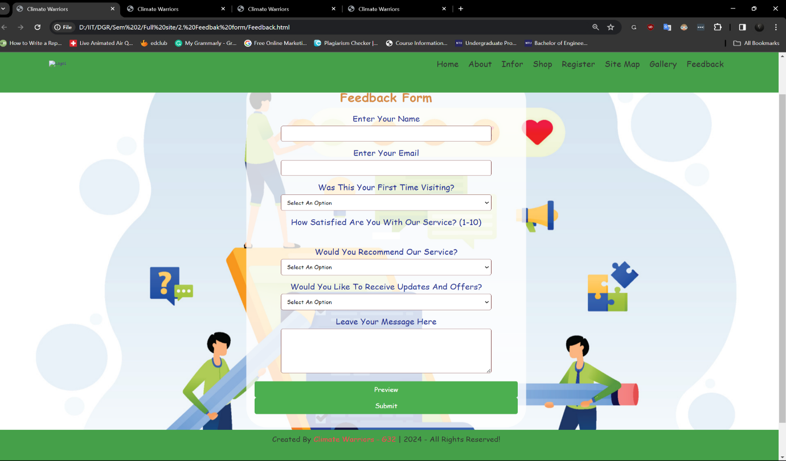

Figure 1 - Feedback Form

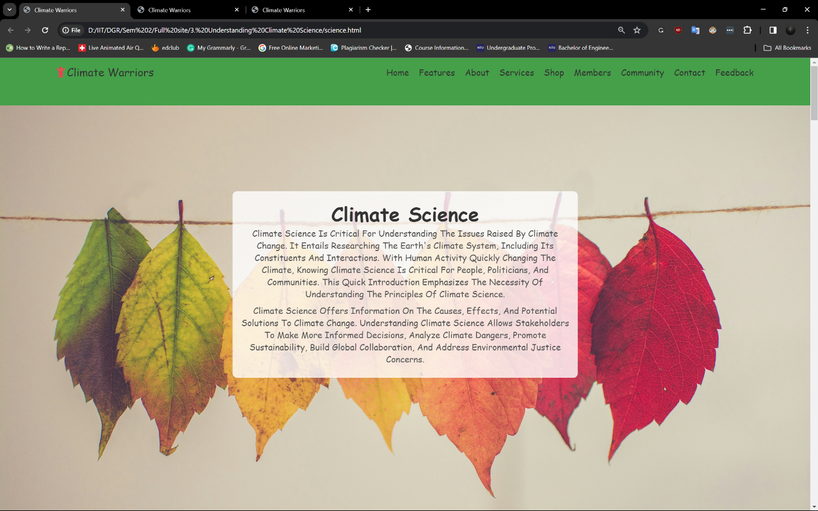

Figure 2 - Content Page 1.1

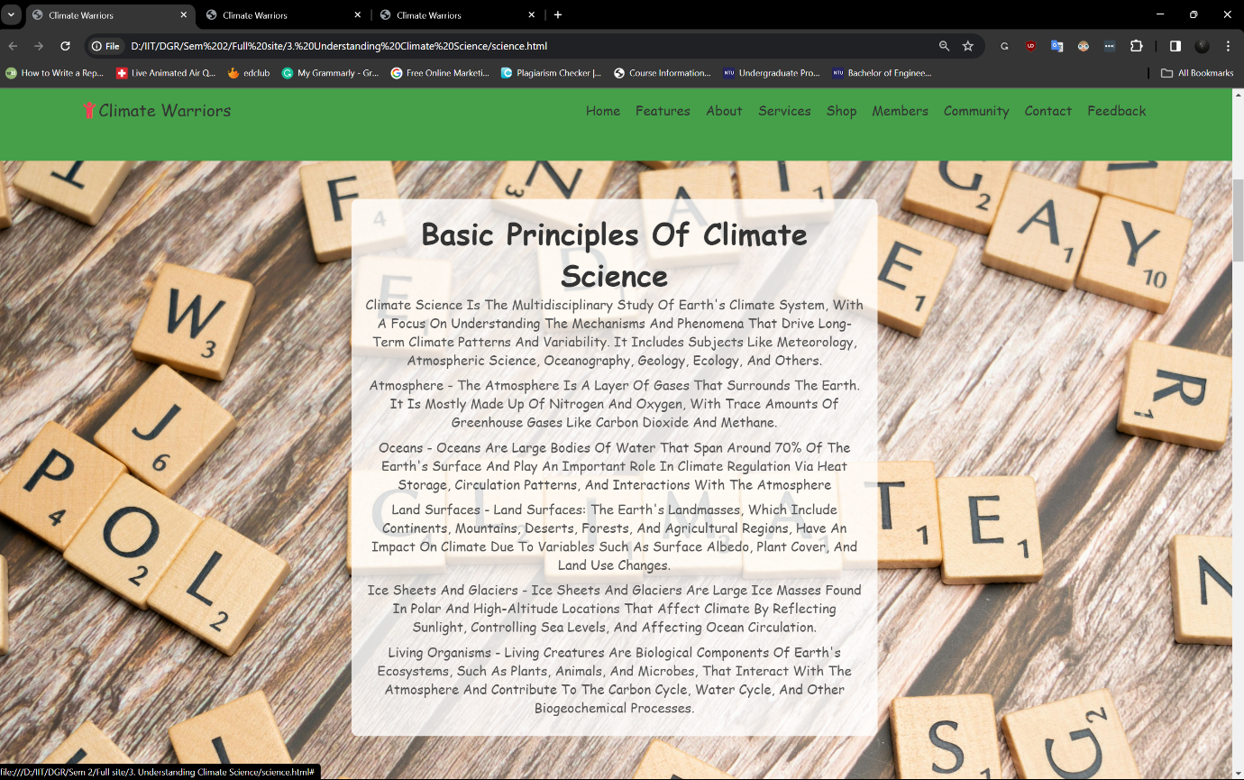

Figure 3 - Content Page 1.2

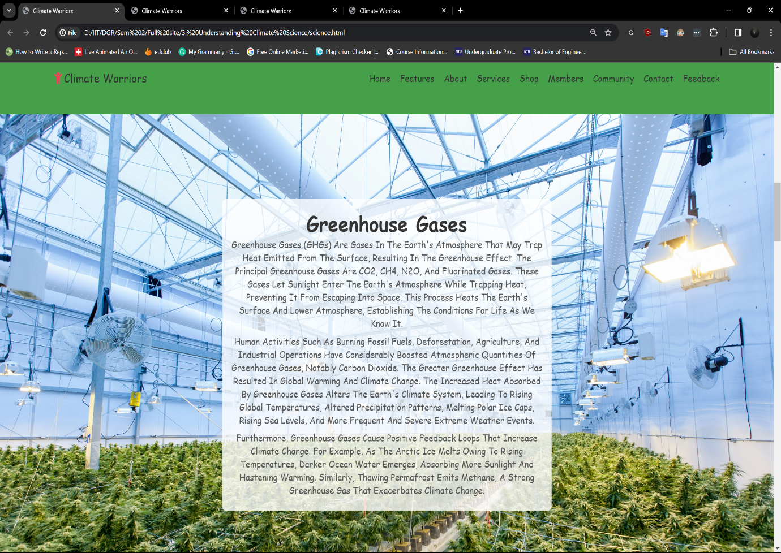

Figure 4 - Content Page 1.3

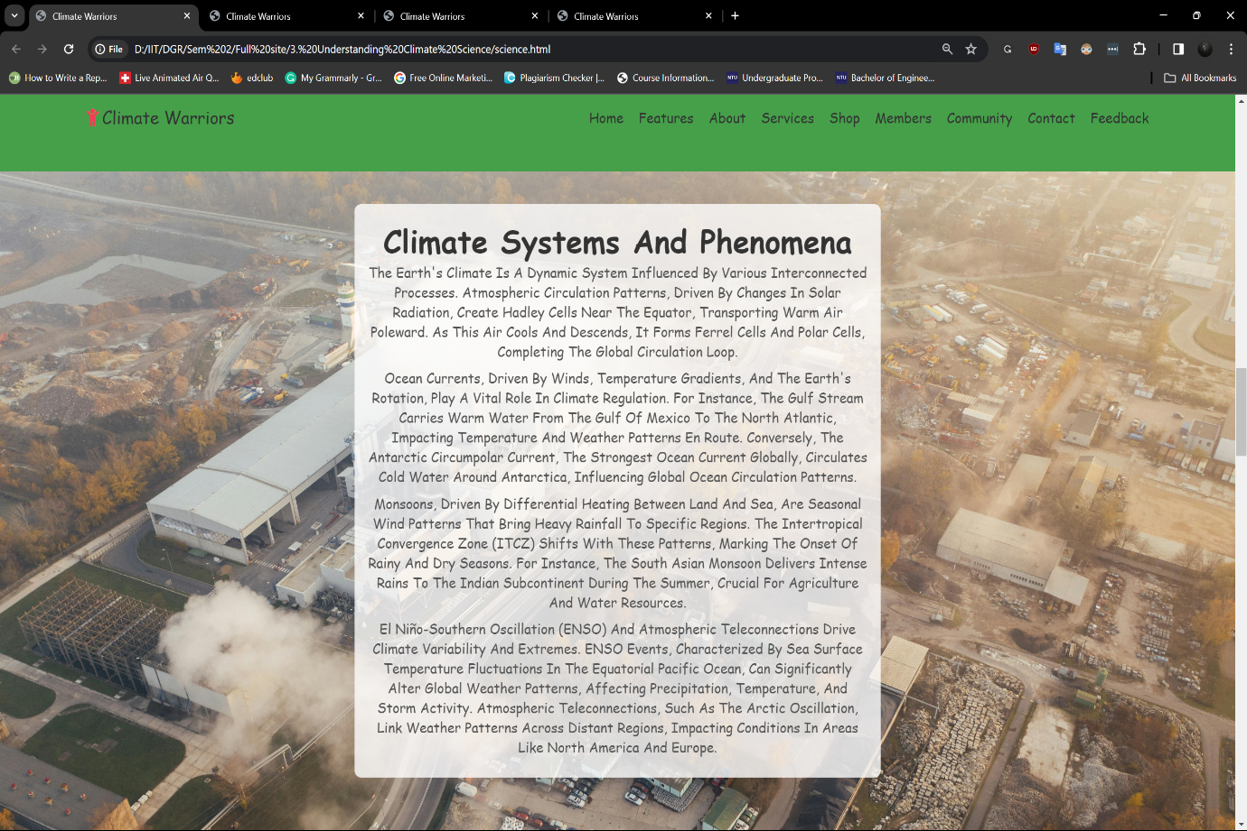

Figure 5 - Content Page 1.4

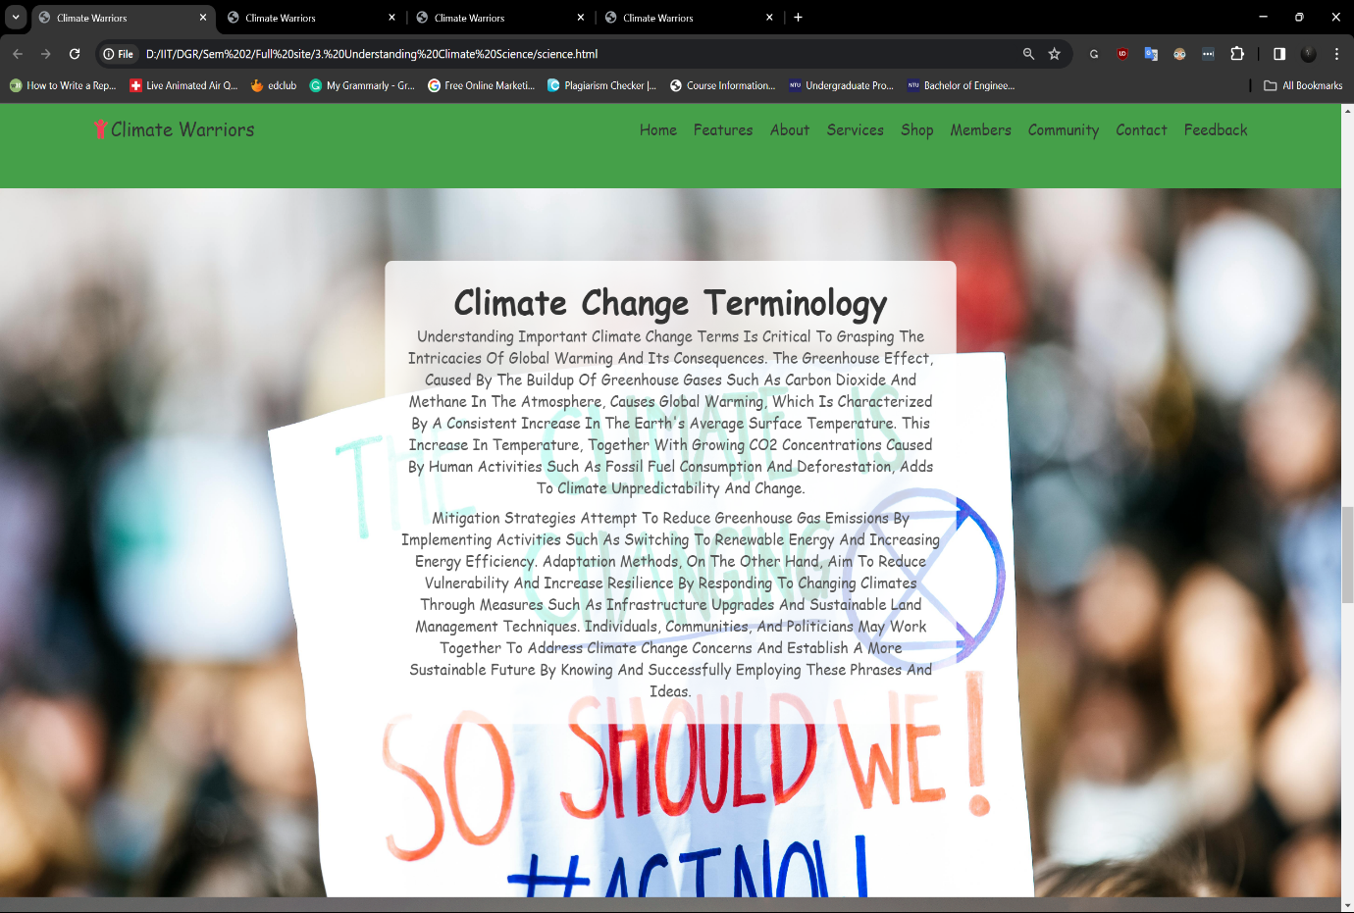

Figure 6 - Content Page 1.5

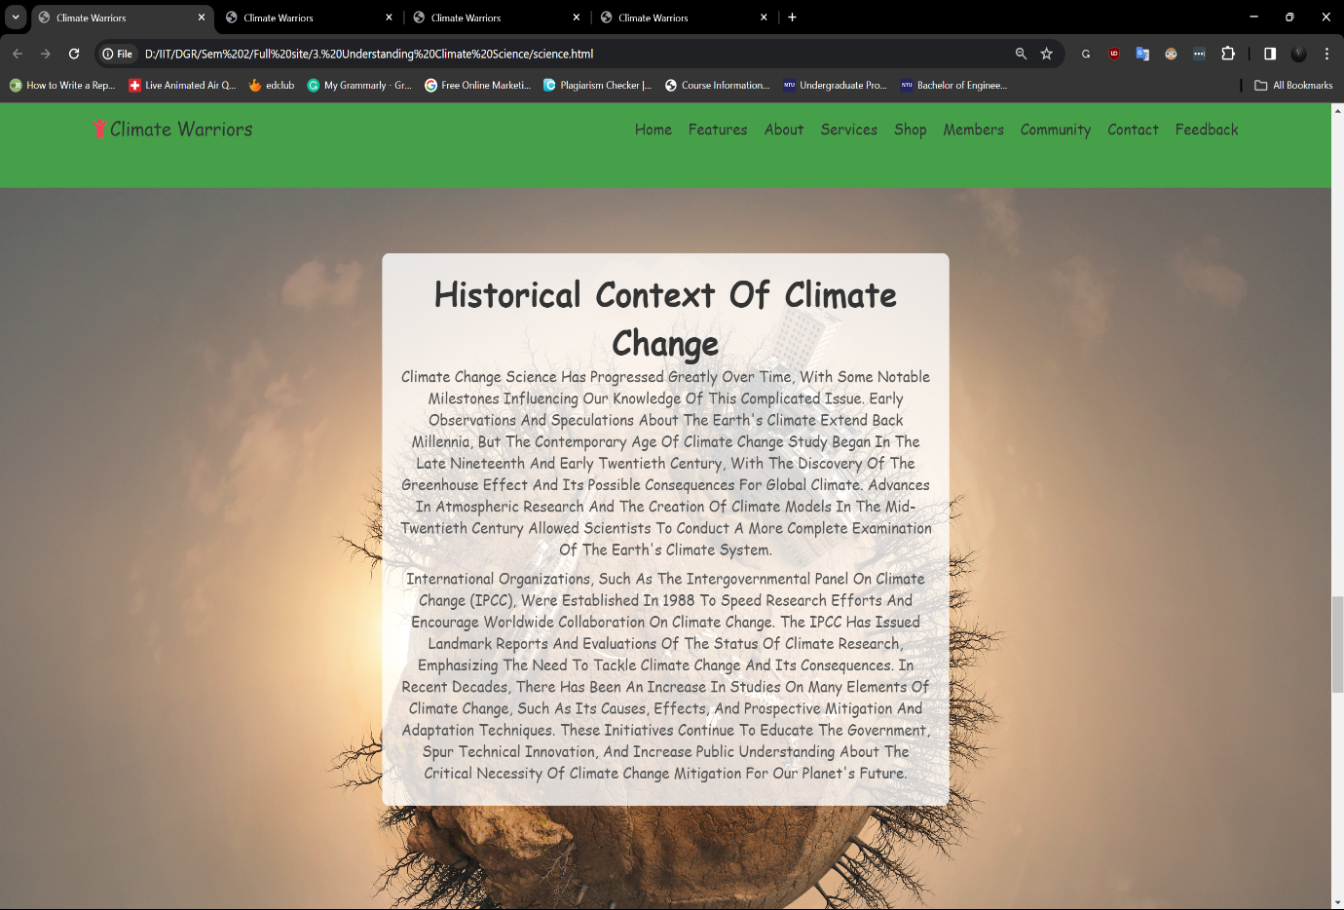

Figure 7 - Content Page 1.6

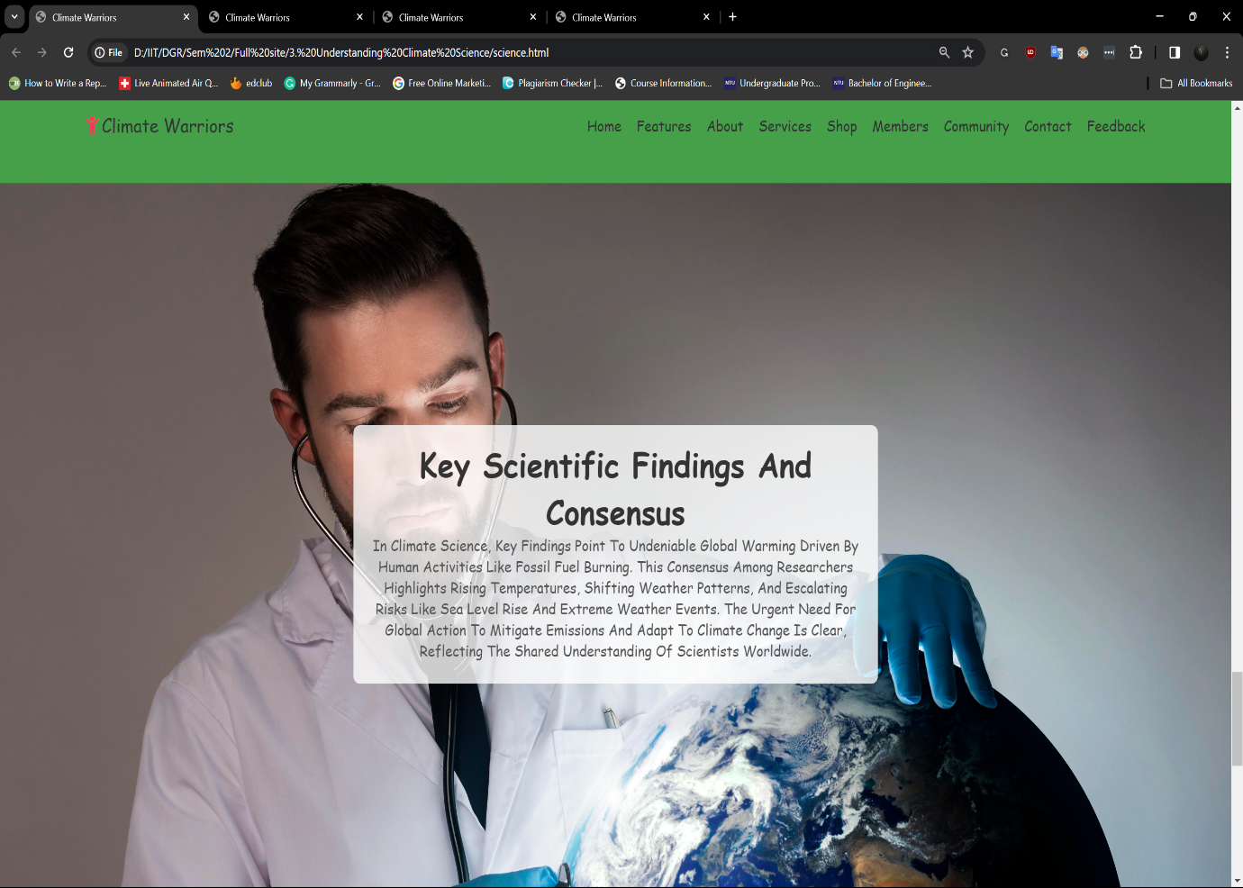

Figure 8 - Content Page 1.7

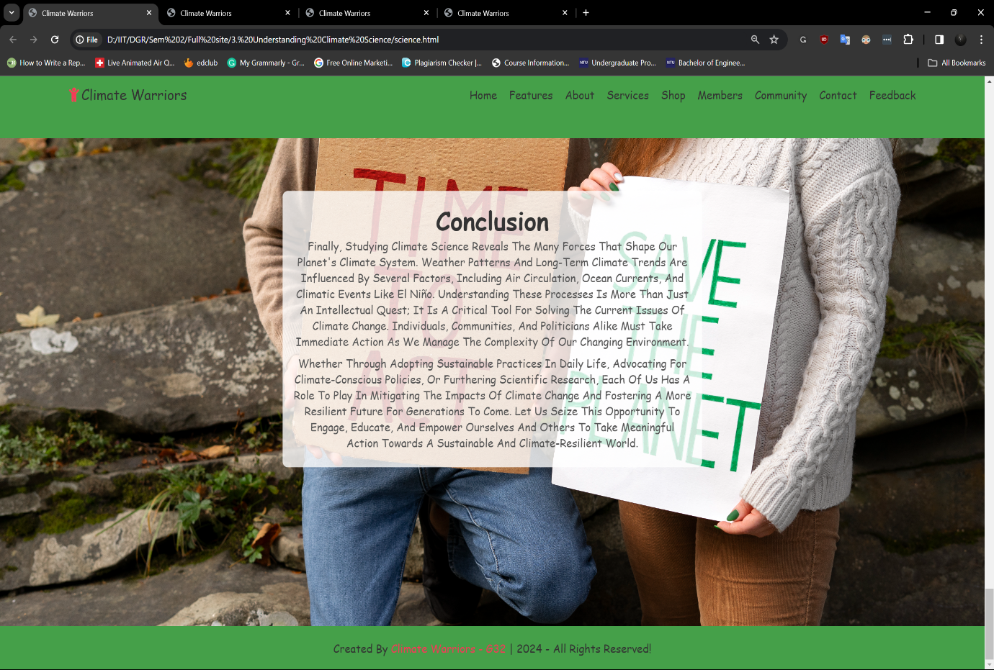

Figure 9 - Content Page 1.8

Home Page

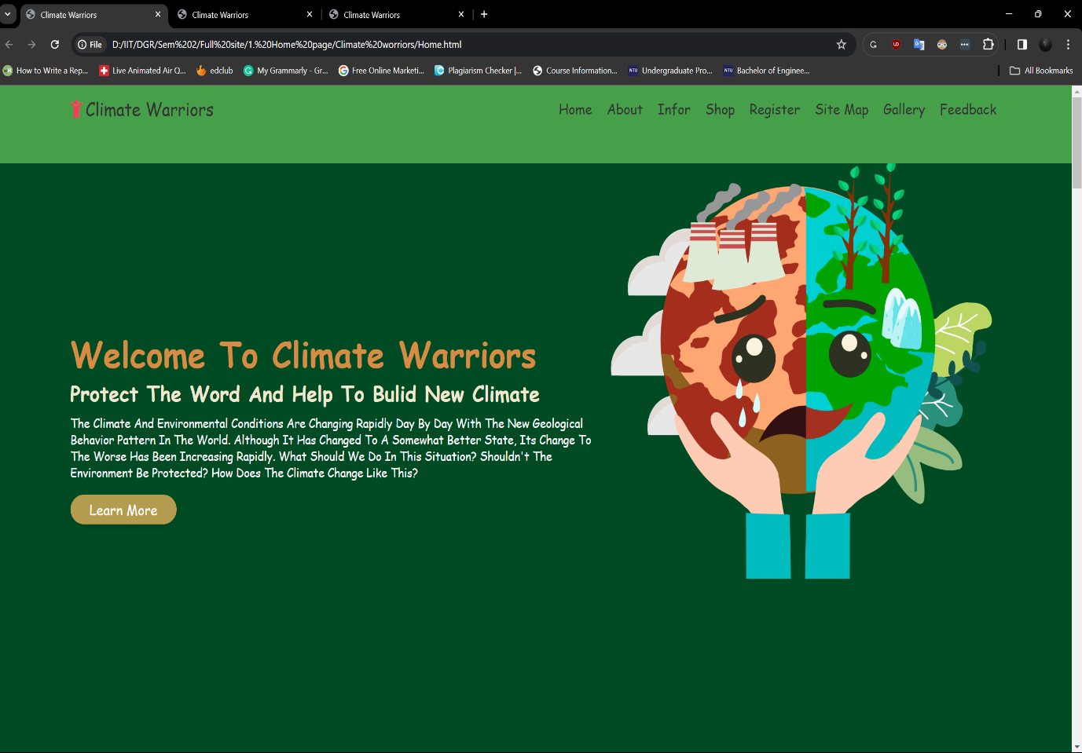

Figure 10 - Home Page 1.1

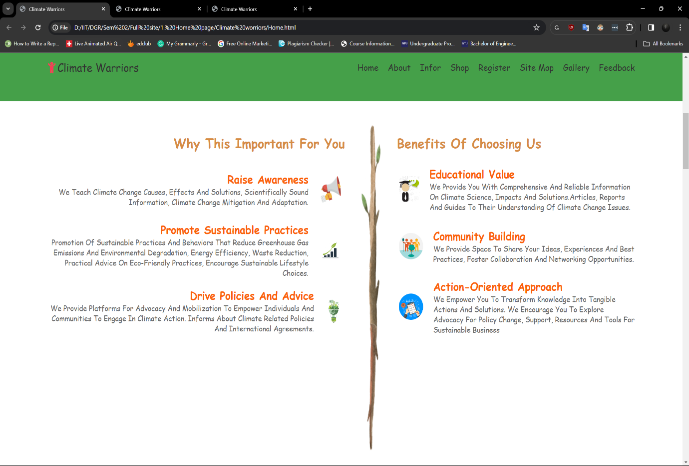

Figure 11 - Home Page 1.2

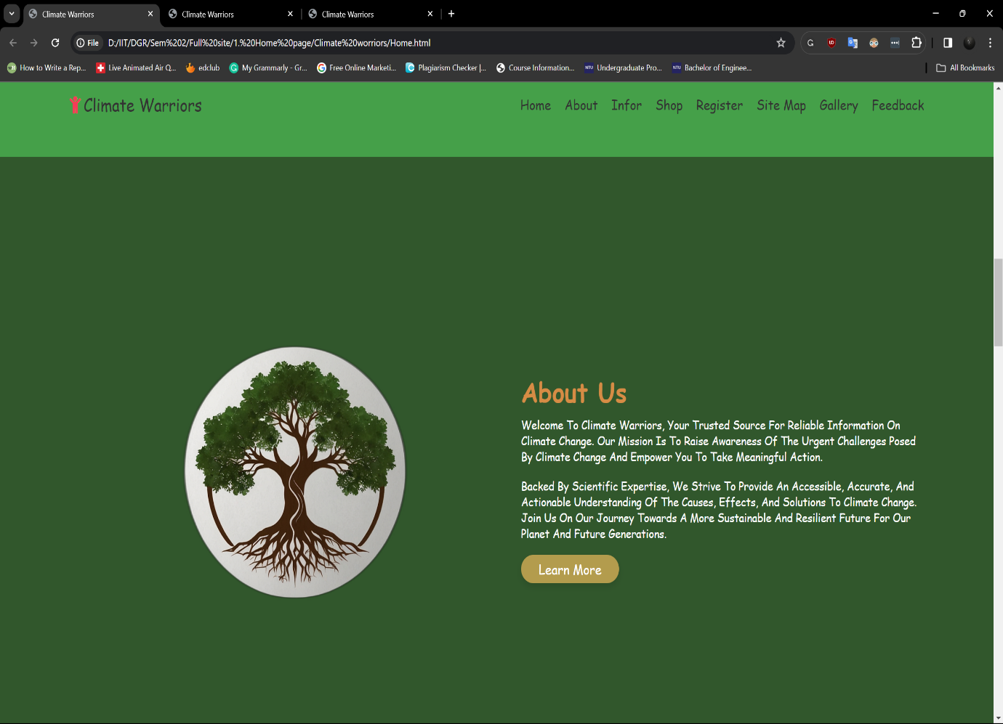

Figure 12 - Home Page 1.3

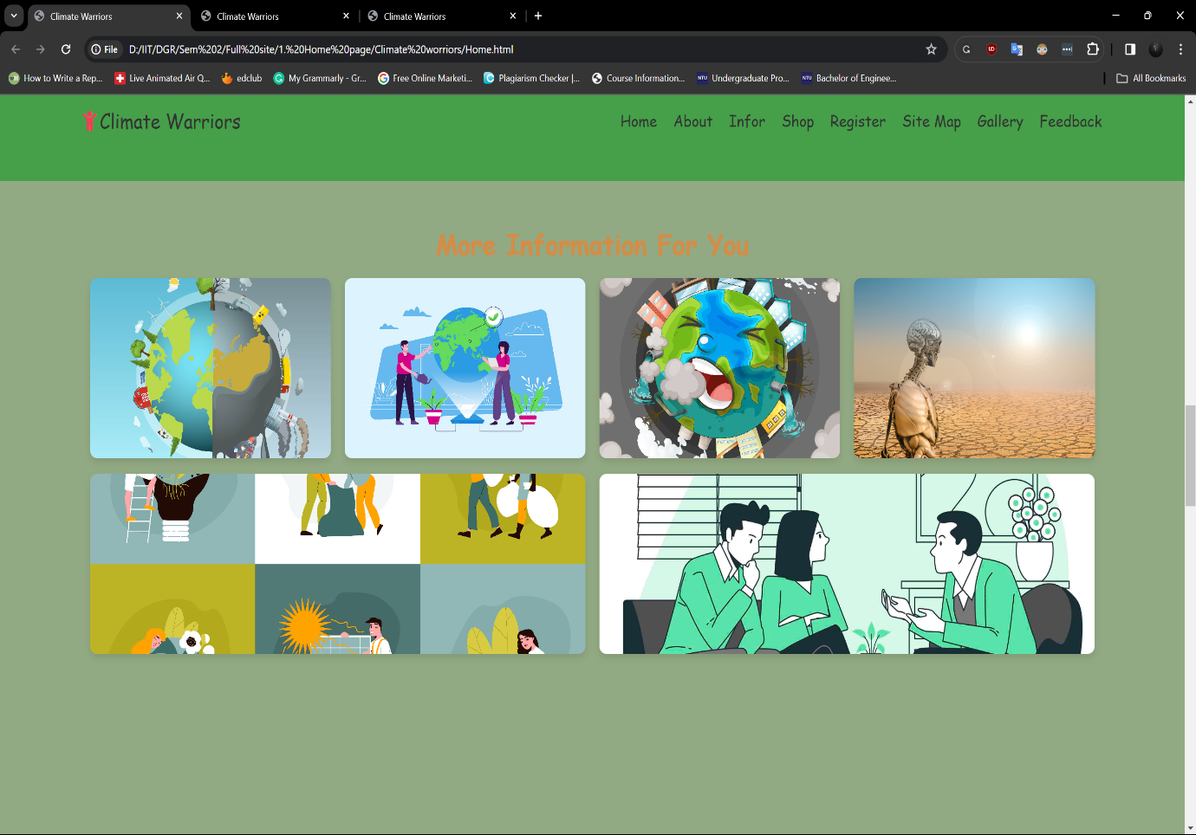

Figure 13 - Home Page 1.4

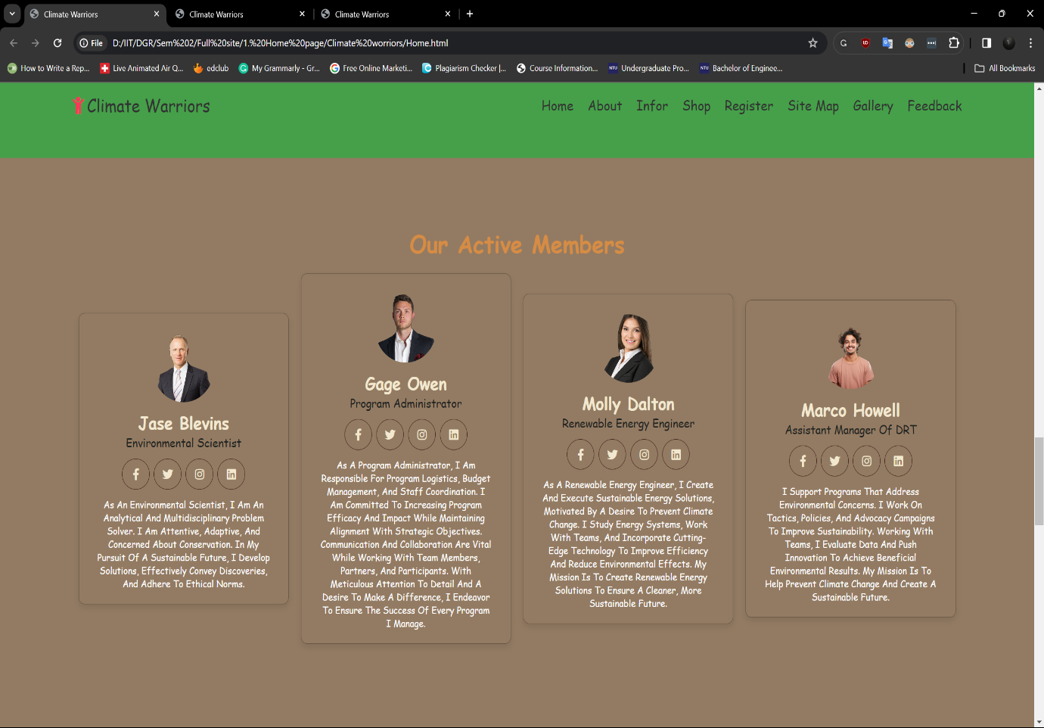

Figure 14 - Home Page 1.5

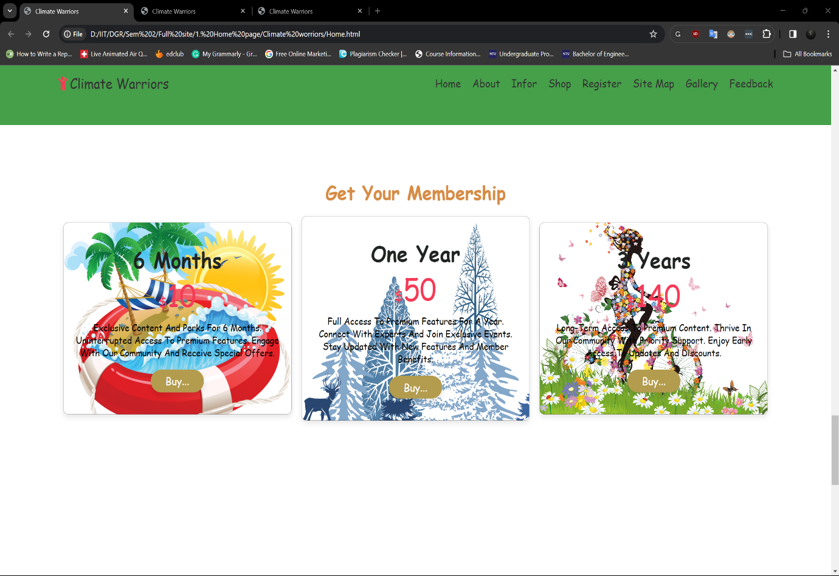

Figure 15 - Home Page 1.6

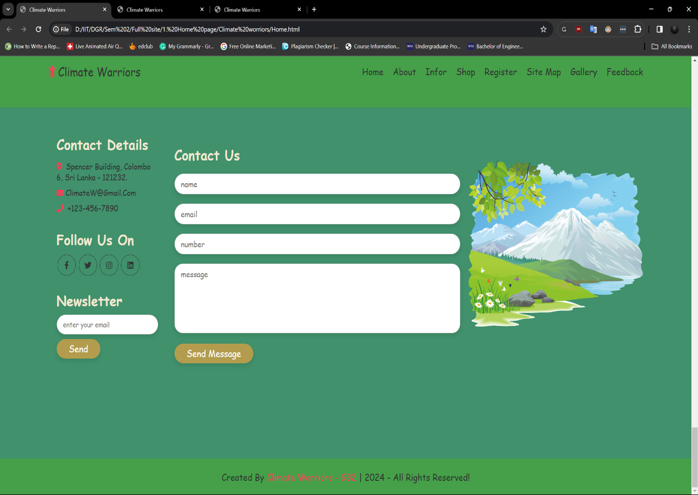

Figure 16 - Home Page 1.7

## Appendix C: Screenshots - Webpage Validation Evidence

Home Page

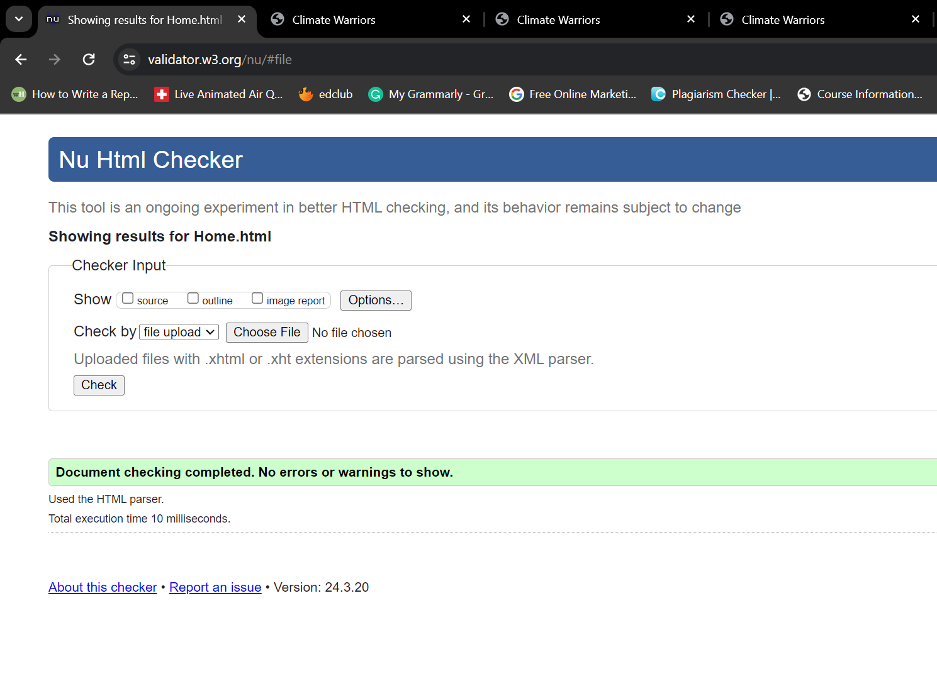

Figure 17 - Home Page Validation

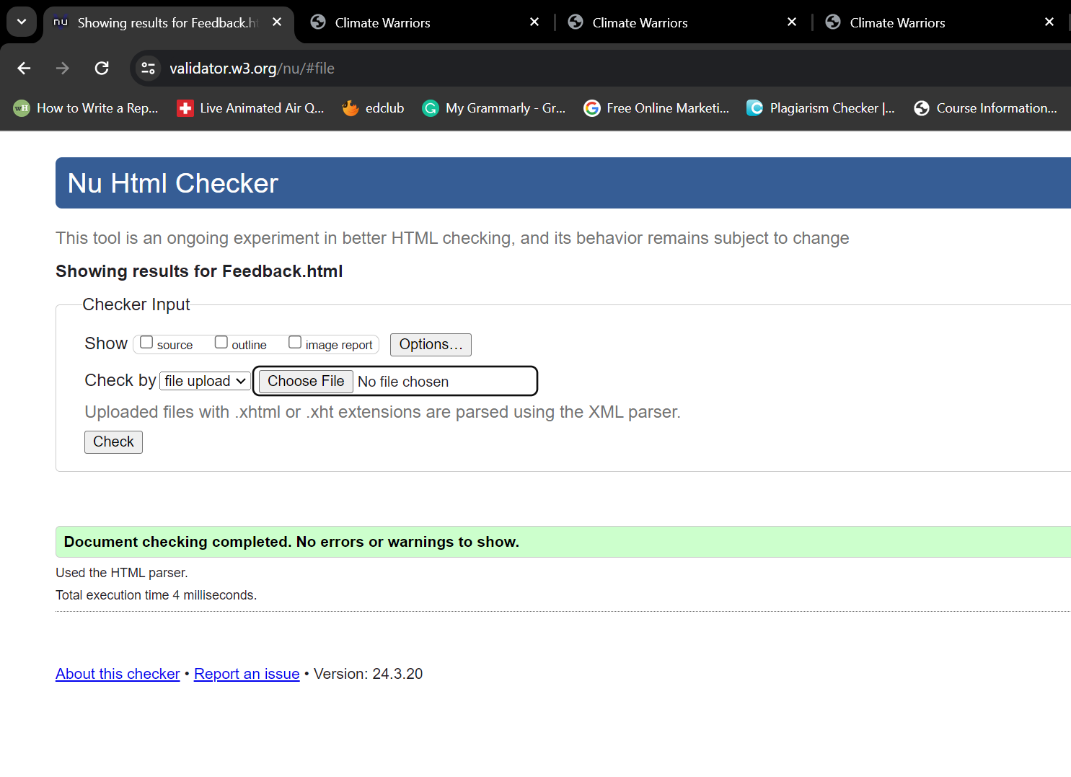

Figure 18 - Feedbak Page Validation

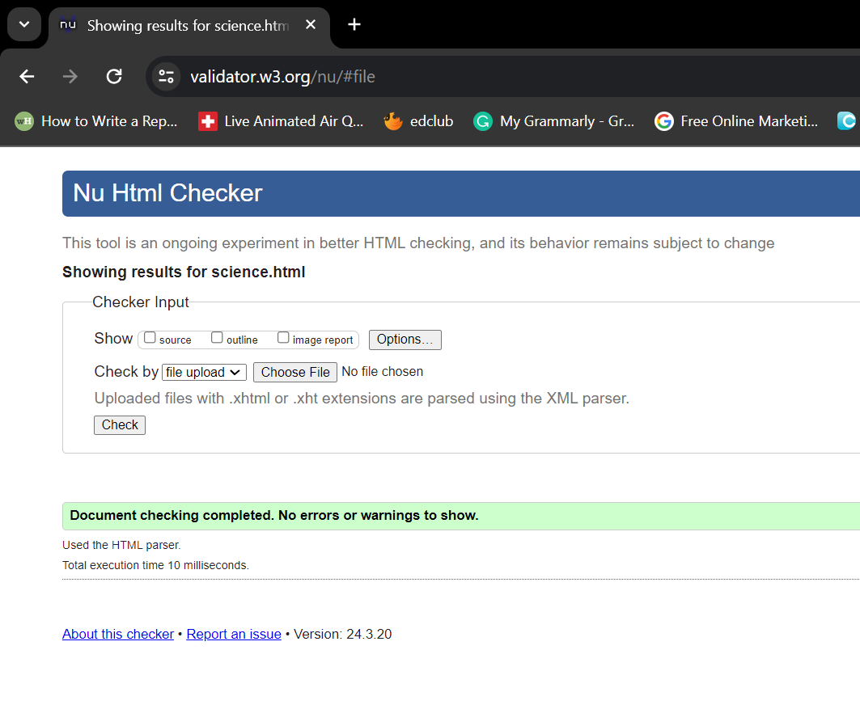

Figure 19 - Content Page 1 Validation

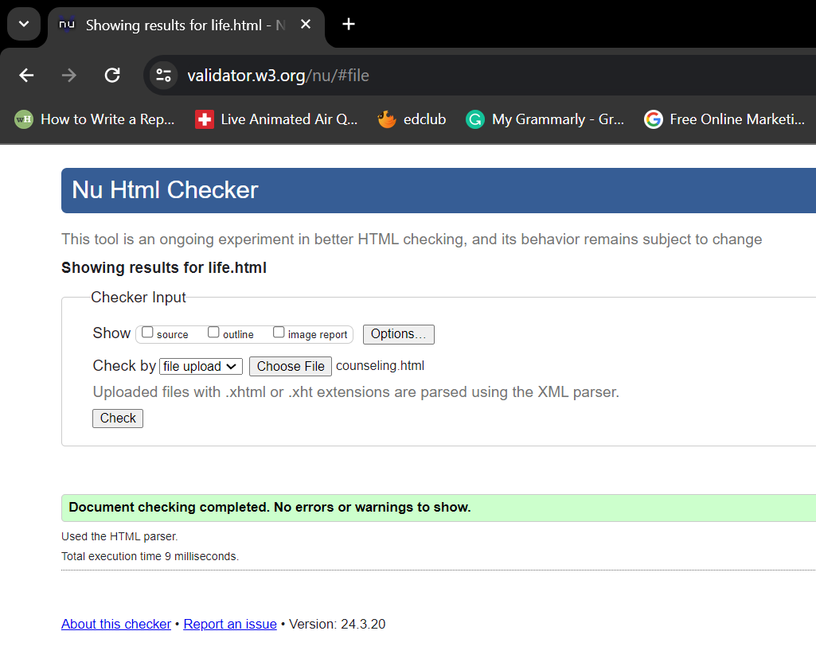

Figure 20 - Content Page 2 Validation

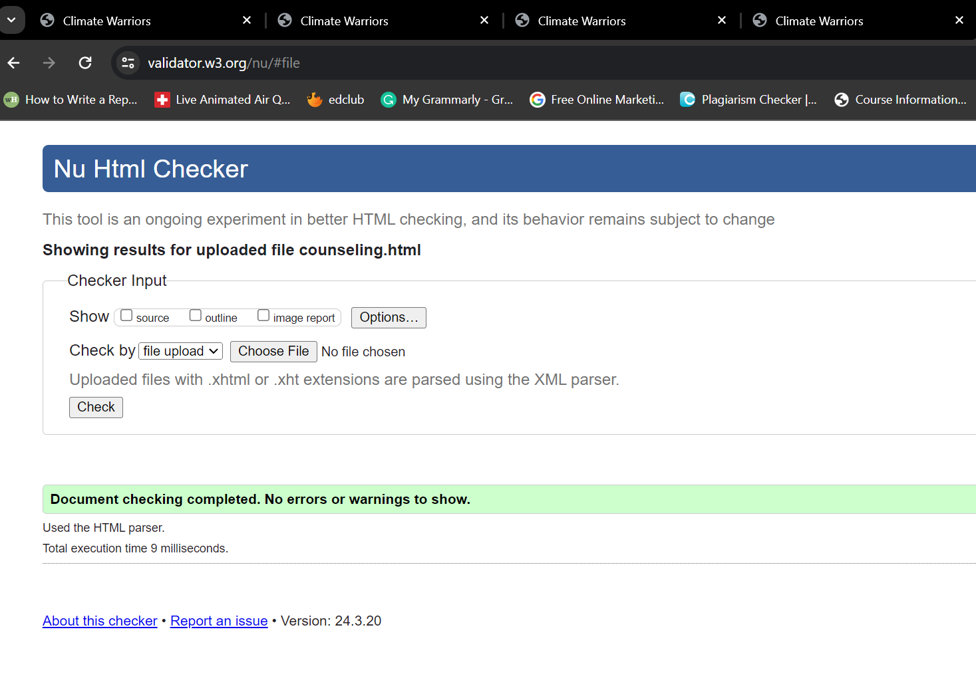

Figure 21 - Content Page 3 Validation

## Appendix D: Task Completion Checklist

|  |  |  |  |  |
| --- | --- | --- | --- | --- |
| **Student 2 Tasks** | **Completed** | | | **Student Comments** |
| **Yes** | **No** | **Partially** |
| 1 – Home Page | **√** |  |  | Create the home page with colorfully and informative. |
| 2 – Navigation bar | **√** |  |  | Create a navigation bar for easy access. |
| 3 – Content page | **√** |  |  | Create 3 content pages for our information section. |
| 4 – Page Editor | **√** |  |  | Write media queries for improve responsiveness. |
| 5 – Provide the navigation bar and utilize it in all pages (adapted) | **√** |  |  | Link all pages with navigation bar. |
| 6 – Provide the template for the website and utilize the template to all pages (adapted) | **√** |  |  | Provide a template for all other members to get and create on their pages. |
| 7 – Additional CSS | **√** |  |  | Write additional CSS for content pages and feedback page to improve responsiveness. |
| 8 – Additional Interactivity | **√** |  |  | Write JavaScript for home page and feedback page to error handling. |
| 9 – Uploaded to Webserver | **-** | **-** | **-** | **-** |

Table 2 - Student 2 Tasks